TABLE OF CONTENTS
DECLARATION ................................................................................................................ iii
CERTIFICATE ................................................................................................................... iv
ACKNOWLEDGEMENT .................................................................................................. v
ABSTRACT ........................................................................................................................ vi
LIST OF FIGURES ........................................................................................................... vii
CHAPTER 1 INTRODUCTION ....................................................................................... 1
1.1 Project Context and Motivation ................................................................................. 1
1.2 Problem Statement ..................................................................................................... 2
1.3 Objectives of the Project ............................................................................................ 3
1.4 Scope of the Project ................................................................................................... 3
1.5 Feasibility Study ........................................................................................................ 3
1.6 Software and Hardware Requirements ...................................................................... 4
CHAPTER 2 TOOLS & TECHNOLOGY USED ............................................................ 6
2.1 Backend Technologies ............................................................................................... 6
2.2 Frontend Technologies ............................................................................................... 6
2.3 Database ..................................................................................................................... 7
2.4 Security and Authentication ....................................................................................... 7
2.5 Cloud and Third-Party Integrations ............................................................................ 7
2.6 Development Tools and Environment ........................................................................ 8
2.7 Deployment Technologies .......................................................................................... 8
CHAPTER 3 IMPLEMENTATION .................................................................................. 9
3.1 System Architecture ................................................................................................... 9
3.2 Layered Backend Architecture ................................................................................... 10
3.3 Database Design ......................................................................................................... 11
3.4 Data Dictionary .......................................................................................................... 13
3.5 Module-wise Description ........................................................................................... 14
3.6 REST API Design ...................................................................................................... 16
3.7 Security Implementation ............................................................................................ 18
3.8 Frontend Implementation ........................................................................................... 20
3.9 Deployment Architecture ........................................................................................... 20
CHAPTER 4 SNAPSHOTS .............................................................................................. 21
4.1 Login Page ................................................................................................................. 21
4.2 Organization Registration .......................................................................................... 22
4.3 Employee Dashboard ................................................................................................. 22
4.4 Admin Dashboard ..................................................................................................... 23
4.5 Employee Management ............................................................................................ 23
4.6 Backlog Page ............................................................................................................. 23
4.7 Kanban Board ........................................................................................................... 24
4.8 Issue Tracker .............................................................................................................. 25
4.9 Sprint Planning .......................................................................................................... 25
4.10 Workflow Designer ................................................................................................. 26
4.11 Reports & Analytics ................................................................................................ 26
4.12 User Profile .............................................................................................................. 27
4.13 Password Reset ........................................................................................................ 27
CHAPTER 5 RESULT AND DISCUSSION .................................................................... 28
5.1 Testing Methodology ................................................................................................. 28
5.2 Functional Test Cases and Results ............................................................................. 28
5.3 Non-Functional Testing .............................................................................................. 29
5.4 Discussion .................................................................................................................. 30
CHAPTER 6 CONCLUSION & FUTURE SCOPE .......................................................... 31
6.1 Conclusion .................................................................................................................. 31
6.2 Future Scope ............................................................................................................... 31
CHAPTER 7 REFERENCES ............................................................................................. 33
APPENDICES .................................................................................................................. 34

LIST OF FIGURES
FIGURE TITLE PAGE NO.
3.1 High-Level System Architecture 9
3.2 Layered (N-Tier) Backend Architecture 10
3.3 Entity-Relationship Diagram 12
3.4 JWT Authentication Sequence 18
3.5 Docker Multi-Stage Build 20
4.1 Login Page 21
4.2 Organization Registration 22
4.3 Employee Dashboard 22
4.4 Admin Dashboard 23
4.5 Employee Management 23
4.6 Backlog Page 24
4.7 Kanban Board 24
4.8 Issue Tracker 25
4.9 Sprint Planning 25
4.10 Workflow Designer 26
4.11 Reports & Analytics 26
4.12 User Profile 27
4.13 Password Reset 27

CHAPTER 1
INTRODUCTION
  - Project Context and Motivation
The Task Management System is a modern, full-stack solution designed to automate and simplify project coordination, issue tracking, sprint planning, and team collaboration within software development organizations. Traditional attendance-style spreadsheets, email threads, and disconnected to-do lists make it difficult for teams to track who is working on what, how a task is progressing, and whether a sprint is on schedule. As teams grow, this lack of structure leads to duplicated effort, missed deadlines, and poor visibility for managers.
Industry-grade tools such as Jira, Trello, Asana, and Linear solve this problem by combining issue tracking, Kanban/Scrum boards, sprint management, and reporting into a single platform. This project was undertaken to design and build a scaled-down, but architecturally sound, version of such a system one that captures the core engineering challenges of a real SaaS product: secure authentication, multi-tenant data isolation, role-based access control, workflow customization, and analytics while remaining simple enough to be developed, understood, and demonstrated within the scope of a B.Tech mini project.
The motivation behind choosing this domain was two-fold. First, project-management software is one of the most common categories of enterprise backend systems, so building one provides hands-on experience with patterns (layered architecture, DTOs, JWT security, ORM-based persistence) that are directly transferable to real Java Full Stack Developer roles. Second, unlike a simple CRUD application, a task-management platform naturally requires solving harder problems such as tenant isolation, IDOR prevention, state-machine-driven workflow transitions, and drag-and-drop board mechanics making it a strong showcase project for both technical depth and practical usability.
  - Problem Statement
Small and medium software teams frequently lack access to a lightweight, self-hosted project-management tool that they fully control and can customize. Commercial SaaS tools like Jira are powerful but come with licensing costs, vendor lock-in, and limited customization at the data layer. There is a need for a self-contained, secure, and extensible task-management platform that:
- Allows multiple organizations (tenants) to use the same deployed instance while keeping each organization's data completely isolated from every other organization.
- Provides a secure, stateless authentication mechanism suitable for both browser clients and future mobile/API clients.
- Supports the core Agile workflow backlog grooming, sprint planning, Kanban/Scrum boards, and burndown/velocity reporting out of the box.
- Enforces role-based permissions so that only authorized users (e.g., Admins, Managers) can perform sensitive operations such as approving new organizations or users.
- Can be deployed easily using containerization for portability across environments.
The “Task Management System” project addresses each of these requirements through a Spring Boot backend with JWT-secured, organization-scoped REST APIs and a responsive HTML/CSS/JavaScript frontend.
  - Objectives of the Project
- To design and implement a secure, JWT-based authentication and authorization system with role-based access control (ADMIN, MANAGER, DEVELOPER, TESTER).
- To build a multi-tenant data model in which every business entity (issues, boards, sprints, workflows) is strictly scoped to its owning organization.
- To implement a two-stage onboarding flow for organizations and users, including administrator approval before account activation.
- To develop full issue-tracking functionality: issue creation, assignment, status transitions, commenting, labeling, and search.
- To implement Kanban board mechanics including configurable columns, WIP limits, and drag-and-drop card movement.
- To implement Agile sprint management: sprint creation, backlog-to-sprint assignment, sprint start/end, and burndown tracking.
- To implement a configurable workflow engine that models allowed status transitions (fromStatus →toStatus) restricted by role.
- To provide analytical reports burndown, velocity, cumulative flow, epic progress, and workload distribution.
- To integrate secure file/attachment upload and storage using the Cloudinary cloud service.
- To containerize the application using Docker for consistent, portable deployment.
  - Scope of the Project
The scope of this project covers the complete backend implementation using Spring Boot, Spring Security, Spring Data JPA, and MySQL, along with a functional frontend built with plain HTML, CSS, and JavaScript that consumes the backend REST APIs. The system supports multiple organizations (tenants), multiple users per organization with distinct roles, multiple projects/boards per organization, and the full Agile lifecycle from backlog to sprint to board to report.
The scope does not include real-time features such as WebSocket-based live collaboration, a native mobile application, or third-party OAuth login providers these are identified as future enhancements in Chapter 6. The current version focuses on demonstrating a production-grade backend architecture and a usable, responsive web frontend rather than a pixel-perfect commercial UI.
  - Feasibility Study
1.5.1 Technical Feasibility
All technologies used in this project Java, Spring Boot, Spring Security, Hibernate, MySQL, HTML/CSS/JavaScript, and Docker are mature, open-source, and well-documented, with strong community support and extensive learning resources. The development environment (Eclipse, Maven, Git) is freely available. No specialized or proprietary hardware is required, so the project is technically feasible to design, build, and demonstrate within the timeframe and resource constraints of a B.Tech mini project.
1.5.2 Economic Feasibility
The entire technology stack is open-source and free to use for development and educational purposes. The only recurring cost in a production deployment would be hosting (e.g., a small cloud VM or PaaS instance) and the free tiers of the MySQL database and Cloudinary storage, both of which comfortably support a demonstration-scale deployment at zero cost. This makes the project economically feasible both for academic submission and for a genuine small-team production rollout.
1.5.3 Operational Feasibility
The system is operable by end users with no specialized training, since the UI follows familiar Agile/Kanban conventions already used by tools like Jira and Trello. From an administrator's perspective, the organization/user approval workflow is simple and self-explanatory. The layered backend architecture also makes the system operationally maintainable by a single developer, which matches the intended usage context.
  - Software and Hardware Requirements
Category | Requirement
Operating System | Windows 10/11, Linux, or macOS (development); any Docker-capable OS (deployment)
Programming Language | Java Development Kit (JDK) 17 or above
IDE | Eclipse IDE for Java Developers (or IntelliJ IDEA / VS Code)
Build Tool | Apache Maven 3.9+ (Maven Wrapper included in repository)
Database Server | MySQL 8.x
Browser | Any modern browser — Google Chrome, Mozilla Firefox, Microsoft Edge
Containerization | Docker Engine 20+ (for containerized deployment)
API Testing Tool | Postman
Version Control | Git, GitHub account
Minimum RAM | 4 GB (8 GB recommended for smooth IDE + MySQL + browser usage)
Minimum Disk Space | 2 GB free space for project, dependencies, and database
Internet Connection | Required for Maven dependency resolution, Cloudinary uploads, and email sending

CHAPTER 2
TOOLS & TECHNOLOGY USED
- Backend Technologies
The backend of the Task Management System is developed entirely in Java 17 using the Spring Boot 3.2.5 framework. Spring Boot was chosen because it drastically reduces boilerplate configuration through auto-configuration and starter dependencies, while still exposing the full power of the underlying Spring ecosystem. The following Spring modules are used:
- Spring Web (spring-boot-starter-web): Provides the embedded Tomcat server and the annotation-driven REST controller layer (@RestController, @RequestMapping) used to expose all APIs.
- Spring Data JPA (spring-boot-starter-data-jpa): Provides repository abstractions over Hibernate ORM, eliminating hand-written SQL/DAO boilerplate for standard CRUD operations.
- Spring Security (spring-boot-starter-security): Provides the authentication/authorization framework, integrated with a custom JWT filter for stateless, token-based security.
- Spring Validation (spring-boot-starter-validation): Provides bean-validation annotations used on request DTOs (e.g., RegisterRequestDTO, LoginRequestDTO).
- Spring Mail (spring-boot-starter-mail): Used by EmailService to send password-reset emails via SMTP (Gmail SMTP in production).
- Spring Cloud OpenFeign (spring-cloud-starter-openfeign): Used to build declarative HTTP clients (IssueClient, UserClient) for inter-module/service communication.
- Frontend Technologies
The frontend is built using plain HTML5, CSS3, and vanilla JavaScript (ES6+) without a heavy frontend framework, keeping the client lightweight and dependency-free. The interface follows a consistent dark-theme design system across all fourteen pages (index, login, organization-register, dashboard, admin-dashboard, employee-management, backlog, board, issues, sprints, workflows, reports, profile, reset-password). Pages communicate with the backend exclusively through the Fetch API, attaching the JWT bearer token to the Authorization header of every authenticated request, and rendering JSON responses dynamically into the DOM.
- Database
MySQL is used as the relational database management system. Spring Data JPA with Hibernate as the ORM provider maps Java entity classes directly to MySQL tables, using `spring.jpa.hibernate.ddl-auto=update` in production to automatically evolve the schema. MySQL was selected for its maturity, wide industry adoption, strong relational-integrity guarantees (foreign keys, unique constraints, indexes), and ease of integration with Spring Boot via the mysql-connector-j driver.
- Security and Authentication
Authentication and authorization are implemented using JSON Web Tokens (JWT) via the io.jsonwebtoken (jjwt) library (jjwt-api, jjwt-impl, jjwt-jackson, version 0.11.5). Passwords are hashed using BCryptPasswordEncoder before being persisted, ensuring that plaintext credentials are never stored. A custom OncePerRequestFilter (JWTAuthenticationFilter) intercepts every incoming request, extracts and validates the bearer token, checks it against a token-blocklist service (for logout/invalidation), and populates the Spring SecurityContext so that downstream controllers can rely on @PreAuthorize-style role checks.
- Cloud and Third-Party Integrations
File and image attachments (e.g., issue attachments) are stored using Cloudinary, a cloud-based media management service, integrated via the cloudinary-http44 SDK. This offloads binary storage from the application server and provides CDN-backed delivery of uploaded files. The system also exposes lightweight integration endpoints (/api/integration/github, /jenkins, /docker, /commit, /pullRequest) that model how the platform could receive webhook-style events from external CI/CD and version-control tools.
- Development Tools and Environment
- IDE: Eclipse IDE for Java Developers (Windows)
- Build Tool: Apache Maven (with the Maven Wrapper, mvnw/mvnw.cmd, committed to the repository)
- Version Control: Git and GitHub (repository: task-management-system)
- API Testing: Postman, used to test and document all REST endpoints during development
- Utility Library: Project Lombok, used to eliminate boilerplate getters/setters/constructors on entity and DTO classes via annotations such as @Data, @Builder, @Getter, and @Setter
- Developer Productivity: Spring Boot DevTools, enabling automatic restarts during local development
- Deployment Technologies
The application is packaged as an executable JAR using the spring-boot-maven-plugin and containerized using Docker. A multi-stage Dockerfile is used: the first stage uses a maven:3.9-eclipse-temurin-17 image to compile and package the application, and the second, much smaller, eclipse-temurin:17-jre image copies only the resulting JAR file, keeping the final runtime image lean. The container exposes port 9999, and all environment-specific configuration — database URL/credentials, mail credentials, Cloudinary keys, and service URLs — is externalized through environment variables (DB_URL, DB_USER, DB_PASSWORD, MAIL_USER, MAIL_PASS, CLOUD_NAME, CLOUD_KEY, CLOUD_SECRET, PORT, APP_BASE_URL), following twelve-factor-app configuration principles and avoiding hardcoded secrets in source control.

CHAPTER 3
IMPLEMENTATION
- System Architecture
The Task Management System follows a classic three-tier web application architecture. The presentation tier is a set of static HTML/CSS/JavaScript pages served directly from Spring Boot's static resource handler (src/main/resources/static). The application tier is the Spring Boot backend, which exposes a REST API and contains all business logic. The data tier is a MySQL relational database accessed through Spring Data JPA/Hibernate. Communication between the frontend and backend happens exclusively over HTTPS using JSON payloads, with JWT bearer tokens used to authenticate every protected request.
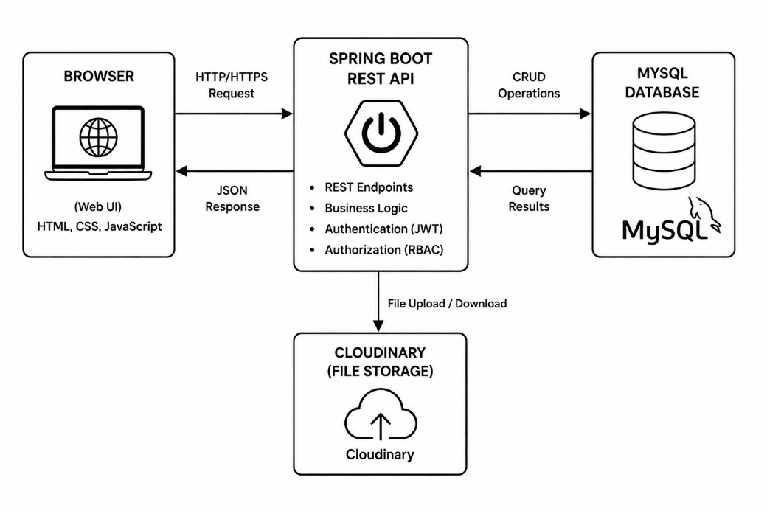
Fig. 3.1: High-Level System Architecture
- Layered Backend Architecture
Within the application tier, the codebase is further organized into a clean, layered structure that separates concerns and improves testability and maintainability:
- Controller Layer: Thin REST controllers (AdminController, IssueController, BoardController, SprintController, WorkFlowController, ReportController, etc.) that map HTTP requests to service calls and return ResponseEntity objects.
- Service Layer: Contains all business logic (AdminService, IssueService, BoardService, SprintService, WorkFlowService, ReportService, UserAuthService, OrganizationService, AttachmentService). Services enforce organization-scoping rules and coordinate multiple repositories.
- Repository Layer: Spring Data JPA interfaces (IssueRepository, BoardRepository, SprintRepository, WorkFlowRepository, UserAuthRepository, etc.) that provide CRUD and derived-query methods without manual SQL.
- Entity Layer: JPA-annotated domain classes mapped one-to-one with MySQL tables (Issue, Board, Sprint, WorkFlow, UserAuth, Organization, etc.).
- DTO Layer: Request/response objects (RegisterRequestDTO, LoginRequestDTO, IssueDTO, AuthResponseDTO, OrganizationRequestDTO, UserProfileUpdateDTO) that decouple the external API contract from internal entity structure.
- Security Layer: SecurityConfig, JWTAuthenticationFilter, JWTUtil, CustomUserDetailsService, TokenBlockService, and RolebasedPermissionConfig, which together implement stateless JWT authentication and role-based authorization.
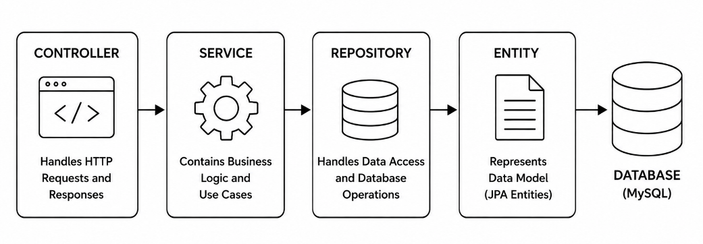
Fig. 3.2: Layered (N-Tier) Backend Architecture
This layering means, for example, that BoardController never talks to BoardRepository directly — it always goes through BoardService, which is where organization-scoping and business rules (such as WIP limit enforcement) are applied. This keeps controllers free of business logic and makes each layer independently unit-testable.

- Database Design
The database schema is generated automatically by Hibernate from the JPA entity classes (`spring.jpa.hibernate.ddl-auto=update`). Every business entity carries an organizationId foreign key, which is the backbone of the system's multi-tenancy model — it ensures that queries can always be filtered to a single tenant's data. Table 3.1 summarizes the major entities and their purpose.
Entity | Purpose
Organization | Represents a tenant. Holds name, unique email, and status (PENDING/ACTIVE/INACTIVE/REJECTED).
UserAuth | Represents an application user — name, unique official email, hashed password, Role, linked Organization, UserStatus, and password-reset token fields.
UserProfileUpdate | Stores extended profile attributes — department, designation, organization, active flag.
Issue | The core work item — unique issueKey, title, description, IssueType, IssuePriority, IssueStatus, assignee/reporter emails, project/sprint/epic/parent linkage, backlog position, organization scope, labels, and due date.
IssueComment | A comment thread entry linked to an Issue, with author email, body text, and timestamp.
Label | A reusable tag (name + organizationId) attached to issues in a many-to-many relationship.
Sprint | An Agile sprint — name, project, organization, start/end dates, and SprintState (PLANNED/ACTIVE/COMPLETED/ABORTED).
Board | A Kanban/Scrum board — name, unique projectKey, organization, BoardType, and an ordered list of BoardColumn entities.
BoardColumn | A column on a board — name, position, WIP limit, and the IssueStatus it represents.
BoardCard | A card placed on a board column, linking a board, an issue, a column, and a position for ordering.
WorkFlow | A named, organization-scoped workflow definition containing an ordered set of WorkFlowTransaction rules.
WorkFlowTransaction | A single allowed status transition (fromStatus → toStatus) with an action name and the set of Roles permitted to perform it.
FileAttachment | Metadata for a file uploaded against an Issue — file name, content type, size, storage path, Cloudinary ID, and uploader.

3.3.1 Key Relationships
- Organization (1) — (∞) UserAuth: one organization has many users; each user belongs to exactly one organization.
- Board (1) — (∞) BoardColumn: a board owns an ordered list of columns.
- BoardColumn (1) — (∞) BoardCard: each column holds many cards, ordered by position.
- Issue (∞) — (∞) Label: issues and labels form a many-to-many relationship via an issue_label join table.
- WorkFlow (1) — (∞) WorkFlowTransaction: a workflow is composed of many allowed from-status → to-status transitions, each restricted to a set of Roles.
- Issue (1) — (∞) IssueComment / FileAttachment: an issue can have many comments and many file attachments.
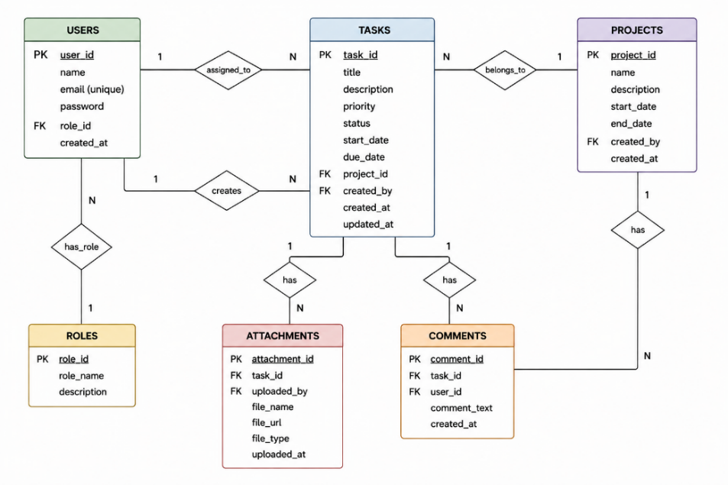
Fig. 3.3: Entity-Relationship overview of the Task Management System schema
- Data Dictionary
This section provides a field-level data dictionary for the principal entities in the system, showing each field's data type/derivation and purpose, as mapped by the JPA annotations in the corresponding entity classes.
3.4.1 Organization
Field | Type | Description
id | Long (PK, Identity) | Auto-generated primary key
name | String (unique, not null) | Organization/tenant name
email | String (unique) | Primary contact email of the organization
status | Enum: OrganizationStatus | PENDING, ACTIVE, INACTIVE, REJECTED
createdAt | LocalDateTime | Registration timestamp

3.4.2 UserAuth
Field | Type | Description
id | Long (PK, Identity) | Auto-generated primary key
userName | String (not null) | Display name of the user
userOfficialEmail | String (unique, not null) | Login identifier
password | String (not null) | BCrypt-hashed password
role | Enum: Role | ADMIN, MANAGER, DEVELOPER, TESTER
organization | Organization (ManyToOne, not null) | Owning tenant
status | Enum: UserStatus | PENDING, ACTIVE, REJECTED, INACTIVE
resetToken / resetTokenExpiry | String / LocalDateTime | Password-reset token and its expiry

3.4.3 Issue
Field | Type | Description
id | Long (PK, Identity) | Auto-generated primary key
issueKey | String (unique, not null) | Human-readable key, e.g., TMS-101
issueTitle / issueDescription | String / String(5000) | Title and detailed description
issueType | Enum: IssueType | TASK, STORY, BUG, EPIC, SUB_TASK
priority | Enum: IssuePriority | LOW, MEDIUM, HIGH, CRITICAL
issueStatus | Enum: IssueStatus | OPEN, TODO, IN_PROGRESS, IN_REVIEW, DONE, CLOSED, REOPENED, BLOCKED, DEPLOYMENT, BLOCKS
assigneeEmail / reporterEmail | String | Owner and creator of the issue
projectId / sprintId / epicId / parentIssueId | Long | Hierarchical / grouping references
backLogPosition | Integer | Ordering position in the backlog
organizationId | Long (not null) | Tenant-scoping key
labels | Set<Label> (ManyToMany) | Tags attached to the issue
createdAt / updatedAt / dueDate | LocalDateTime | Audit and scheduling timestamps

- Module-wise Description
3.5.1 Authentication & User Management Module
Implemented by UserAuthController, UserAuthService, and the Security package. Handles registration, login, forgot-password, and reset-password flows. On registration, a new UserAuth row is created with UserStatus.PENDING; the user cannot log in until an administrator approves the account via AdminController. On successful login, UserAuthService verifies the BCrypt-hashed password and JWTUtil issues a signed JWT embedding the user's email and role, returned to the client inside an AuthResponseDTO.
3.5.2 Organization (Multi-Tenancy) Module
Implemented by OrganizationController and OrganizationService. A prospective tenant registers via /api/organizations/register, creating an Organization row with OrganizationStatus.PENDING. Only after platform-level approval does the organization move to ACTIVE, at which point its users can be approved and can log in. Every downstream entity (Issue, Board, Sprint, WorkFlow, Label, FileAttachment) carries an organizationId, and every service method resolves this ID from the authenticated principal's JWT claims — never from a client-supplied request parameter — which is the core defense against IDOR (Insecure Direct Object Reference) attacks across tenants.
3.5.3 Issue Management Module
Implemented by IssueController, IssueService, and IssueRepository. Supports creating issues of type TASK, STORY, BUG, EPIC, or SUB_TASK, each with a priority (LOW/MEDIUM/HIGH/CRITICAL) and a status drawn from a ten-state lifecycle (OPEN, TODO, IN_PROGRESS, IN_REVIEW, DONE, CLOSED, REOPENED, BLOCKED, DEPLOYMENT, BLOCKS). Issues can be assigned to users by email, linked to a parent/epic issue for hierarchy, commented on, labeled, and searched via query parameters.
3.5.4 Kanban Board Module
Implemented by BoardController and BoardService. A Board (SCRUM or KANBAN type) owns an ordered list of BoardColumn entities, each mapped to an IssueStatus and an optional WIP (work-in-progress) limit. BoardCard rows link issues to a specific column and position, enabling drag-and-drop reordering through the /api/boards/{boardId}/card/{cardId}/move endpoint, which updates both the column and position fields transactionally.
3.5.5 Backlog Module
Implemented by BackLogController and BackLogService. Presents all unscheduled issues for a project ordered by backLogPosition, supports drag-and-drop reordering, and allows moving a backlog item into an active or planned sprint. It also exposes a hierarchy endpoint that groups sub-tasks under their parent stories/epics.
3.5.6 Sprint Module
Implemented by SprintController and SprintService. Supports creating a sprint with a start and end date, assigning backlog issues to it, starting and ending sprints (which drives SprintState transitions PLANNED → ACTIVE → COMPLETED), and computing burndown data by tracking remaining work over the sprint's date range.
3.5.7 Workflow Module
Implemented by WorkFlowController and WorkFlowService. Each organization can define custom WorkFlow objects composed of WorkFlowTransaction rules, each specifying a fromStatus, a toStatus, an actionName (e.g., “Start Progress,” “Send for Review”), and the set of Roles permitted to trigger it. When a client calls PATCH /api/issues/{id}/status, IssueService consults the applicable WorkFlow to verify that the requested transition is both valid and permitted for the caller's role before mutating the issue's status — implementing a lightweight, data-driven state machine.
3.5.8 Reporting Module
Implemented by ReportController and ReportService. Provides analytical endpoints for burndown reports (remaining work vs. time for a sprint), velocity reports (completed story points per sprint for a project), sprint summary reports, epic progress reports, cumulative flow diagrams, and workload distribution reports (issue count per assignee).
3.5.9 File Attachment Module
Implemented by FileAttachmentController, AttachmentService, and the Cloudinary package (StorageService/StorageServiceImpl). Files uploaded against an issue are streamed to Cloudinary, and the returned secure URL/public ID is persisted in the FileAttachment entity alongside metadata (file name, content type, size, uploader). Both direct-link and streamed download endpoints are provided.
3.5.10 Integration Module
Implemented by IntegrationController and IntegrationService. Provides webhook-style endpoints to accept simulated events from external tools — GitHub, Jenkins, Docker, commits, and pull requests — illustrating how the platform could be extended to automatically update issue status based on CI/CD or VCS activity in a production deployment.
3.6 REST API Design
All APIs follow REST conventions, using appropriate HTTP verbs (GET for reads, POST for creation, PUT/PATCH for updates, DELETE for removal) and returning JSON. Table 3.2 lists a representative subset of the exposed endpoints; the complete set spans eleven controllers covering authentication, organizations, admin approval, issues, boards, backlog, sprints, workflows, reports, attachments, and integrations.
Endpoint | Method | Description
/api/user-auth/register | POST | Register a new user under an organization
/api/user-auth/login | POST | Authenticate and issue a JWT
/api/user-auth/forgot-password | POST | Initiate password-reset email flow
/api/user-auth/reset-password | POST | Reset password using a reset token
/api/organizations/register | POST | Register a new organization (PENDING status)
/api/organizations | GET | List organizations
/api/admin/pending-users | GET | List users awaiting admin approval
/api/admin/approve/{userId} | PUT | Approve a pending user
/api/admin/reject/{userId} | PUT | Reject a pending user
/api/issues/createIssue | POST | Create a new issue
/api/issues/{id} | GET | Fetch an issue by ID
/api/issues/assignee/{email} | GET | List issues assigned to a user
/api/issues/{id}/comment | POST | Add a comment to an issue
/api/issues/{id}/status | PATCH | Transition issue status via workflow
/api/issues/search | GET | Search/filter issues
/api/boards | POST | Create a board
/api/boards/{id} | GET | Fetch board details
/api/boards/{boardId}/columns | GET | List columns of a board
/api/boards/{boardId}/cards/{columnId} | GET | List cards in a column
/api/boards/{id}/card | POST | Add a card to a board
/api/boards/{boardId}/card/{cardId}/move | PUT | Move a card (drag-and-drop)
/api/backlog/{projectId} | GET | Fetch the project backlog
/api/backlog/{projectId}/reorder | POST | Reorder backlog items
/api/backlog/add-to-sprint/{issueId}/{sprintId} | PUT | Move a backlog issue into a sprint
/api/sprints/create | POST | Create a new sprint
/api/sprints/{sprintId}/start | PUT | Start a sprint
/api/sprints/{sprintId}/end | PUT | End a sprint
/api/sprints/{sprintId}/burndown | GET | Get sprint burndown data
/api/workflows/create | POST | Create a workflow
/api/workflows/{id}/transactions | GET | List workflow transitions
/api/report/burndownReport/{sprintId} | GET | Burndown report
/api/report/velocityReport/{projectId} | GET | Velocity report
/api/report/workLoadReport/{sprintId} | GET | Workload distribution report
/api/attachments/upload/{issueId} | POST | Upload a file attachment to an issue
/api/attachments/download/{id} | GET | Download an attachment

3.7 Security Implementation
Security is the most carefully engineered aspect of this project, given the multi-tenant nature of the platform. The implementation combines several complementary mechanisms:
3.7.1 JWT Authentication Flow
On successful login, JWTUtil generates a signed JWT containing the user's email and role as claims. For every subsequent request, JWTAuthenticationFilter (a Spring OncePerRequestFilter) reads the Authorization: Bearer <token> header, validates the token's signature and expiry via JWTUtil.validateToken(), confirms the token has not been explicitly revoked using TokenBlockService (which supports logout-time token blocklisting), loads the corresponding UserDetails via CustomUserDetailsService, and populates the SecurityContextHolder with an authenticated principal — all without creating a server-side session, keeping the API fully stateless (SessionCreationPolicy.STATELESS).
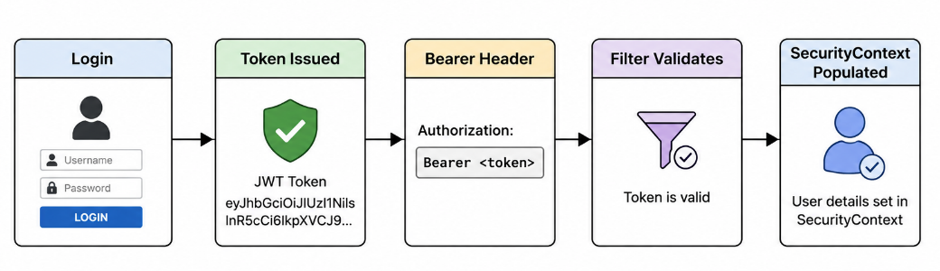
Fig. 3.4: JWT Authentication Sequence
3.7.2 Password Security
All user passwords are hashed with BCryptPasswordEncoder before being persisted; plaintext passwords are never stored or logged. Password-reset uses a time-bound resetToken/resetTokenExpiry pair on the UserAuth entity, emailed to the user via EmailService, rather than exposing the new password over an insecure channel.
3.7.3 Role-Based Access Control (RBAC)
SecurityConfig defines explicit access rules: public endpoints (registration, login, password reset, organization registration, and static HTML/CSS/JS assets) are permitted without authentication; /api/admin/** is restricted to users with the ADMIN role; and every other endpoint requires a valid, authenticated JWT. RolebasedPermissionConfig additionally maps fine-grained Permission values (ISSUE_CREATE, ISSUE_EDIT, ISSUE_ASSIGN, ISSUE_DELETE, COMMENT_ADD, COMMENT_DELETE, USER_MANAGE) to Roles, and workflow transitions further restrict which role may perform which status change. Table 3.3 summarizes the coarse-grained role capabilities.
Role | Capabilities
ADMIN | Full system access; approve/reject organizations & users; manage all modules
MANAGER | Create/manage sprints, boards, workflows; assign issues; view all reports
DEVELOPER | Create/update assigned issues; move board cards; comment; upload attachments
TESTER | View and update issue status for QA workflow transitions; add comments

3.7.4 Multi-Tenant Data Isolation & IDOR Prevention
The most significant security property of this system is strict tenant isolation. Rather than trusting an organizationId supplied in the request body or URL (which a malicious client could tamper with to access another tenant's data), every service method resolves the caller's organization from the authenticated JWT principal on the server side and applies it as a mandatory filter to every repository query and every entity written. This design eliminates a whole class of Insecure Direct Object Reference (IDOR) vulnerabilities where User A of Organization 1 could otherwise guess or enumerate the numeric ID of an Issue/Board/Sprint belonging to Organization 2 and access or modify it.
3.7.5 CORS Configuration
CorsConfigurationSource is configured to allow all origin patterns and standard HTTP methods (GET, POST, PUT, PATCH, DELETE, OPTIONS) with credentials disabled, suitable for a public JSON API consumed by the bundled static frontend and, potentially, external clients during development and demonstration.
  - Frontend Implementation
The frontend is implemented as a set of self-contained HTML pages, each paired with inline or linked CSS following a shared dark-theme design system (deep background tones, accent colors for priority/status badges, card-based layouts) and vanilla JavaScript modules that call the backend using the Fetch API. The JWT returned at login is stored client-side and attached as a bearer token to every subsequent request; on 401/403 responses the frontend redirects the user back to the login page. Key pages include the landing page (index.html), authentication pages (login.html, reset-password.html), the organization onboarding page (organization-register.html), the employee dashboard (dashboard.html) and admin dashboard (admin-dashboard.html), the employee-management page for admins, and the core work-management pages: backlog.html, board.html, issues.html, sprints.html, workflows.html, reports.html, and profile.html.
  - Deployment Architecture
The application is deployed using a two-stage Docker build. In the build stage, a maven:3.9-eclipse-temurin-17 image resolves dependencies (mvn dependency:go-offline) and compiles the project (mvn clean package -DskipTests) to produce a runnable Spring Boot JAR. In the runtime stage, a slim eclipse-temurin:17-jre base image copies only the compiled JAR (TaskManagement-0.0.1-SNAPSHOT.jar) and starts it with `java -jar app.jar`, exposing port 9999. All secrets and environment-specific values are injected at container-start time via environment variables, keeping the image itself free of credentials and making it safe to build in a public CI pipeline and push to a container registry.
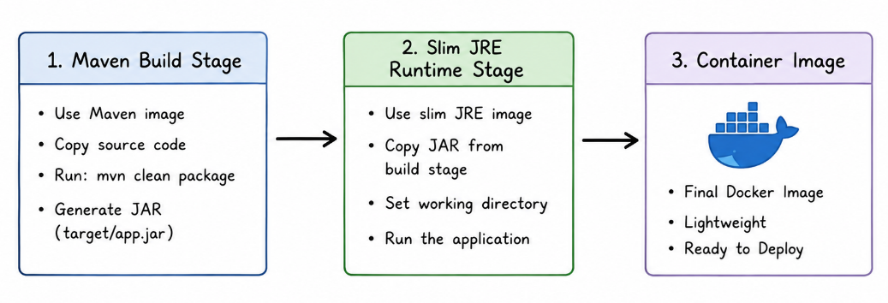
Fig. 3.5: Docker Multi-Stage Build

CHAPTER 4
SNAPSHOTS
This chapter presents the thirteen screens that make up the Task Management System frontend, in the order a typical user would encounter them — from public landing and authentication, through organization onboarding and administration, to the core Agile work-management screens. Each screenshot placeholder below marks where a live capture of the running application (npm/mvn spring-boot:run, opened in a browser) should be inserted; the accompanying description explains the screen's purpose and the backend APIs it drives.

4.1 Login Page
Provides a form for registered users to authenticate with their official email and password. On submit, it calls POST /api/user-auth/login, stores the returned JWT, and redirects the user to their role-appropriate dashboard (Admin Dashboard for ADMIN, Employee Dashboard otherwise). It also links to the forgot-password flow.
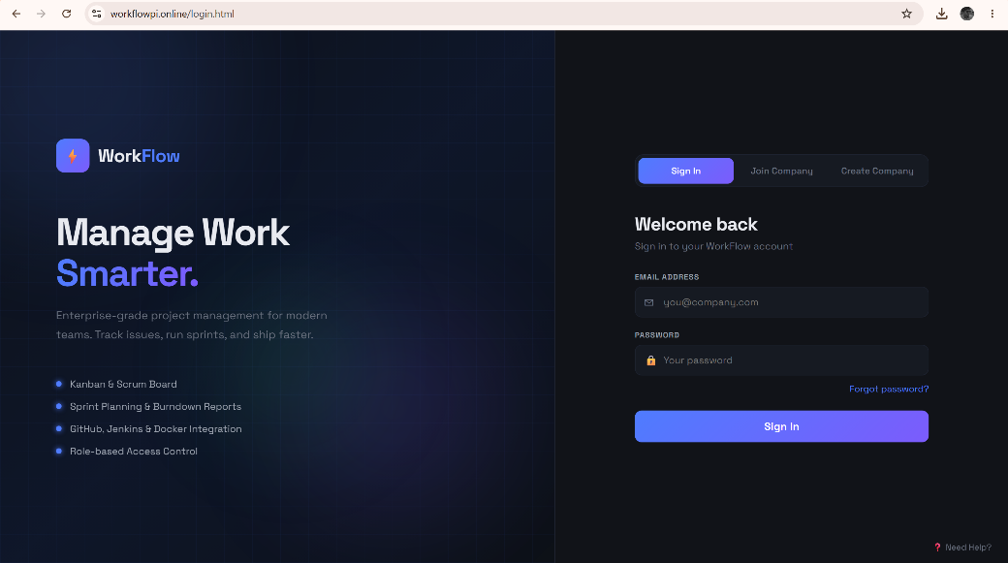
Fig. 4.1: Login Page

4.2 Organization Registration
Allows a new company/team to register as a tenant on the platform by submitting an organization name and contact email. The submission creates an Organization record with PENDING status, awaiting platform-level approval before the organization's users can be activated.
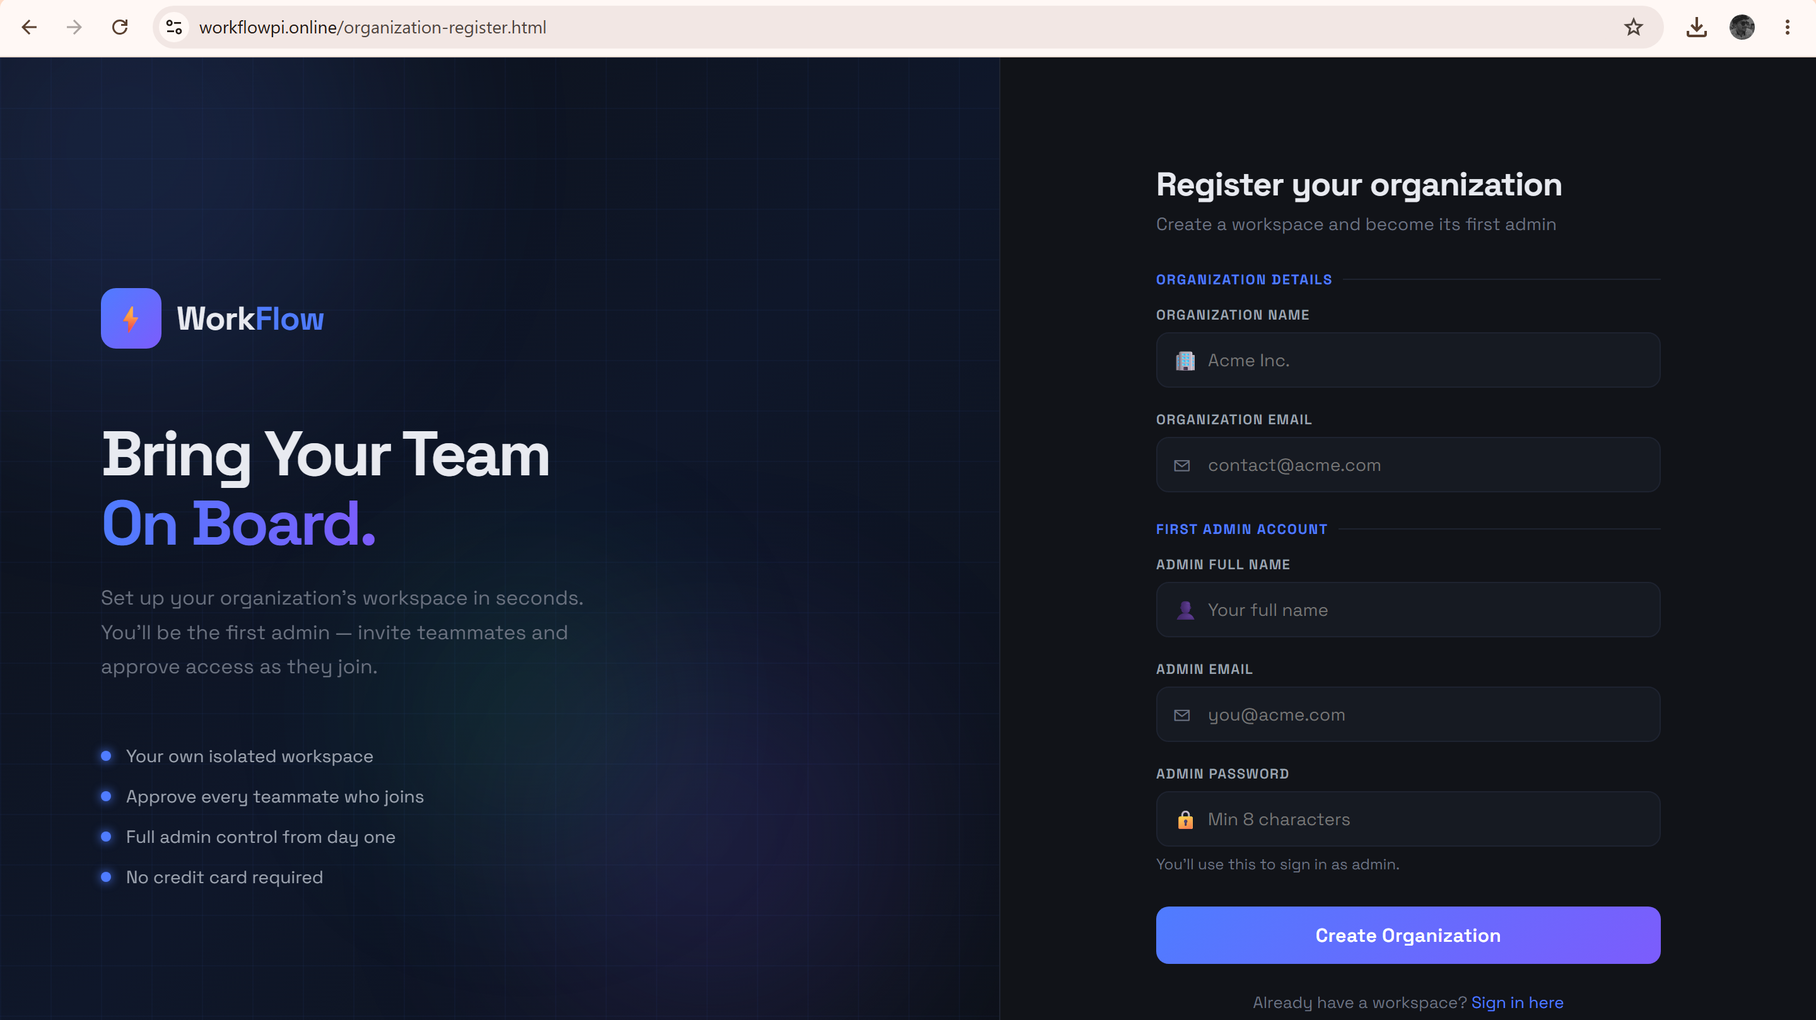
Fig. 4.2: Organization Registration

4.3 Employee Dashboard
The main landing page for an authenticated non-admin user. It surfaces a summary of the user's assigned issues, active sprint progress, and quick links to the Board, Backlog, Sprints, and Issues pages.
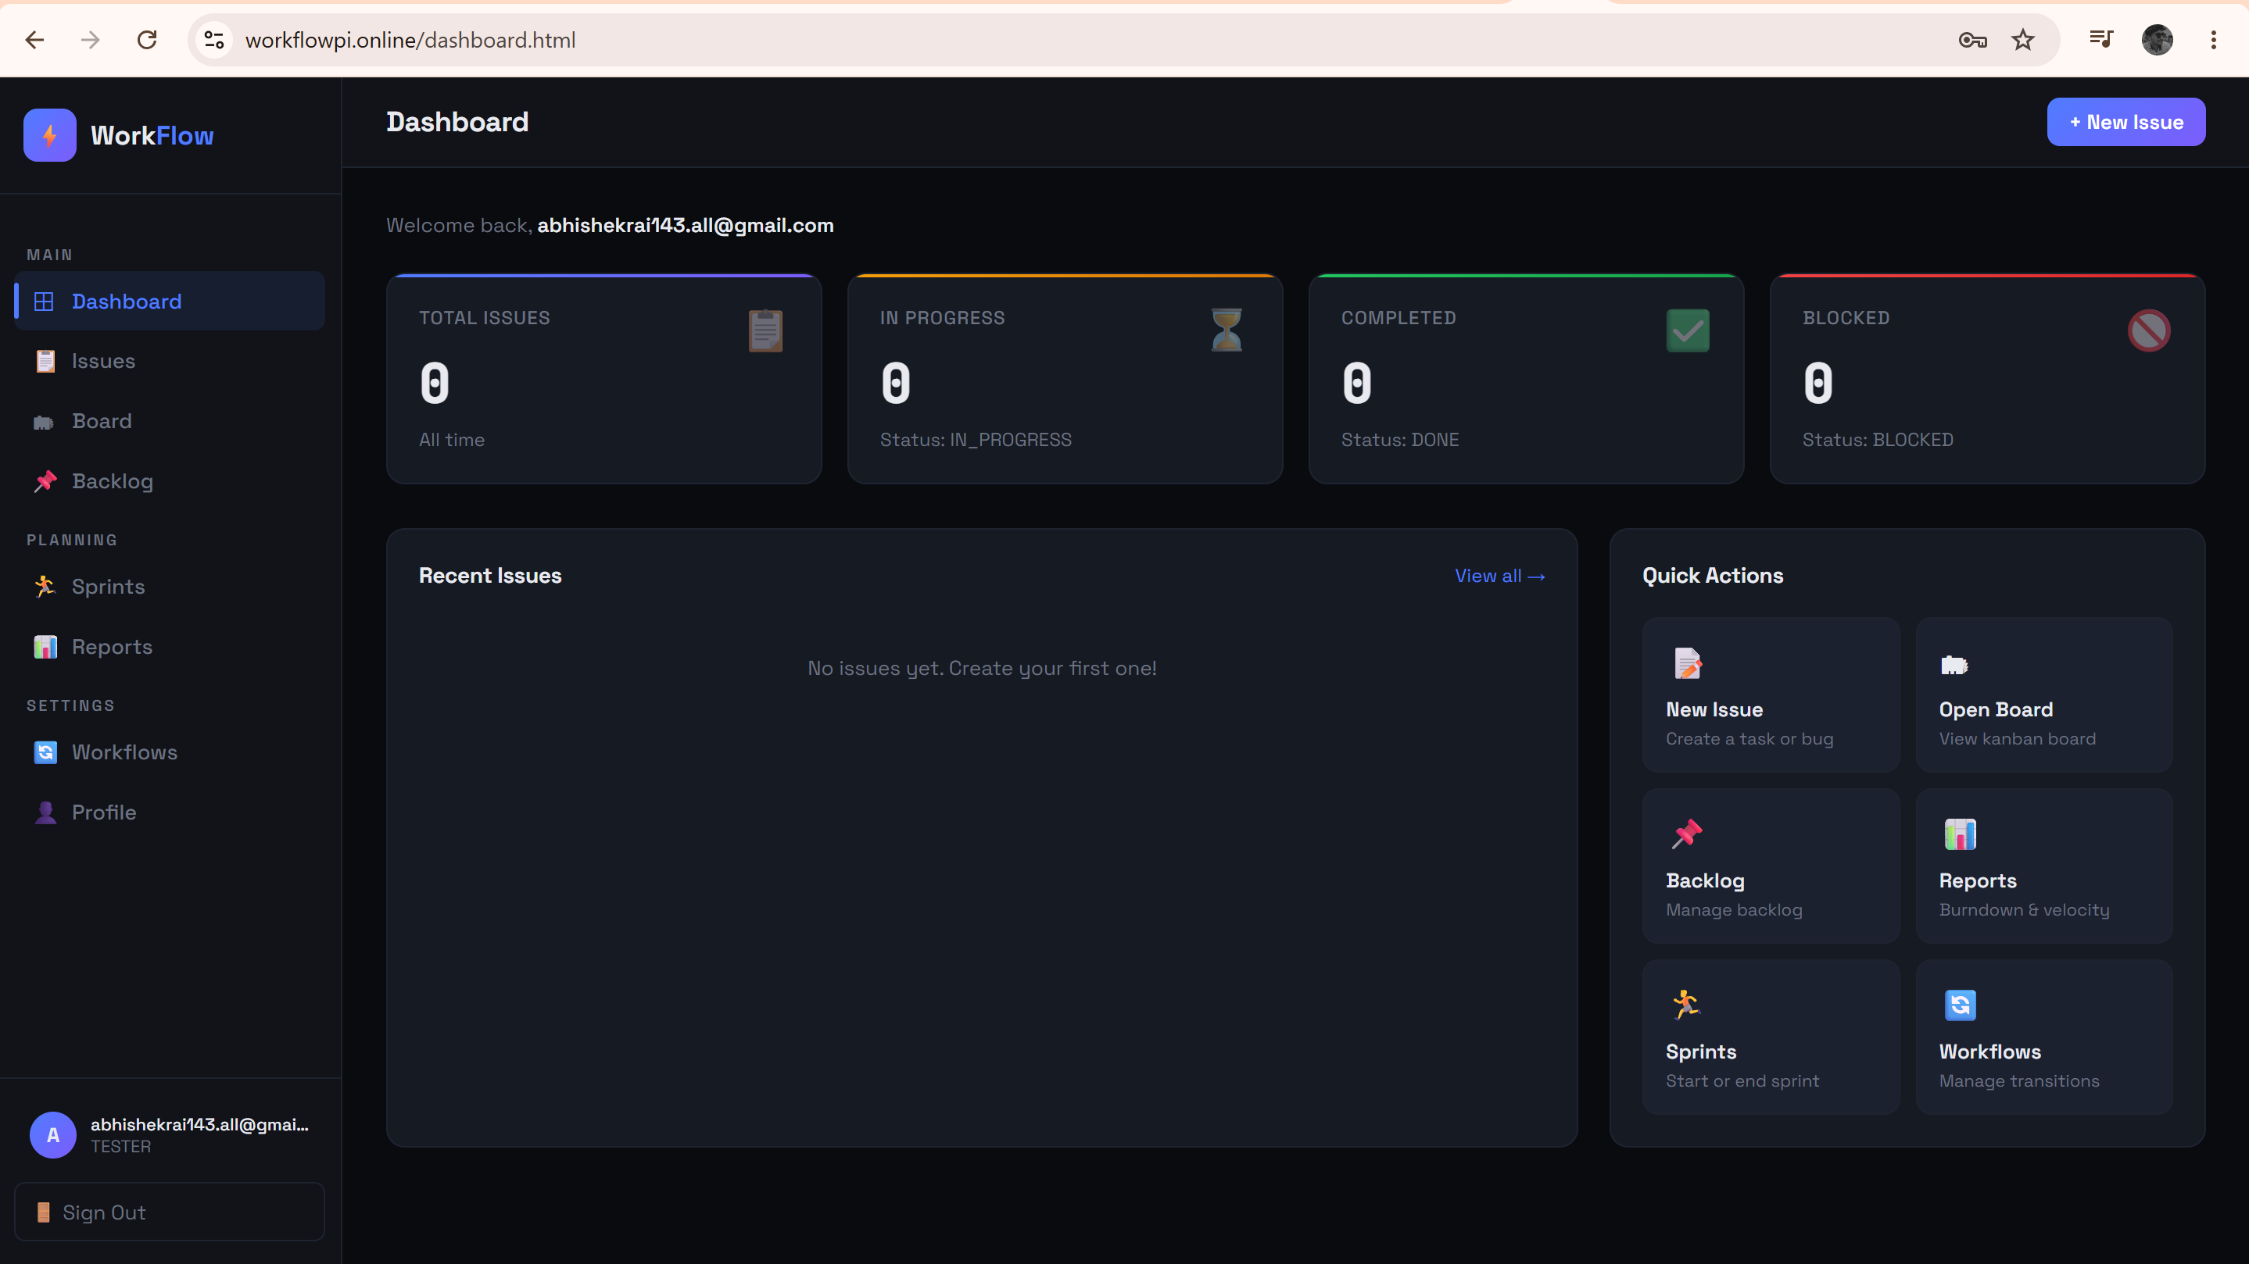
Fig. 4.3: Employee Dashboard

4.4 Admin Dashboard
Visible only to users with the ADMIN role (enforced both by SecurityConfig's /api/admin/** rule and by client-side routing). Displays pending organization/user approvals, high-level organization statistics, and administrative shortcuts, calling GET /api/admin/pending-users and the approve/reject endpoints.

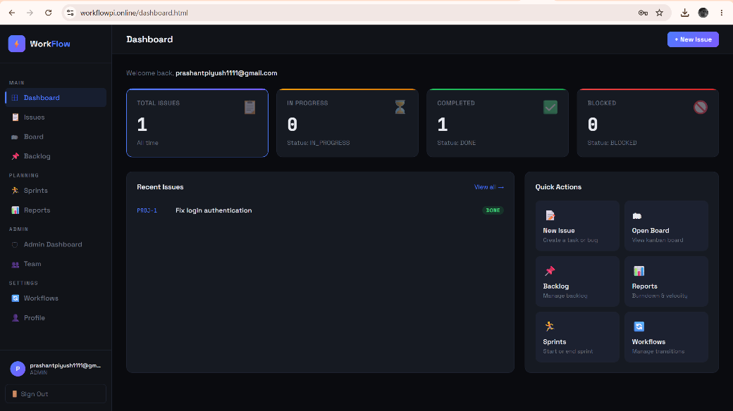
Fig. 4.4: Admin Dashboard

4.5 Employee Management
Allows administrators to view all users within their organization, see their role and status, and manage their profile attributes (department, designation) via the UserProfileUpdate APIs.
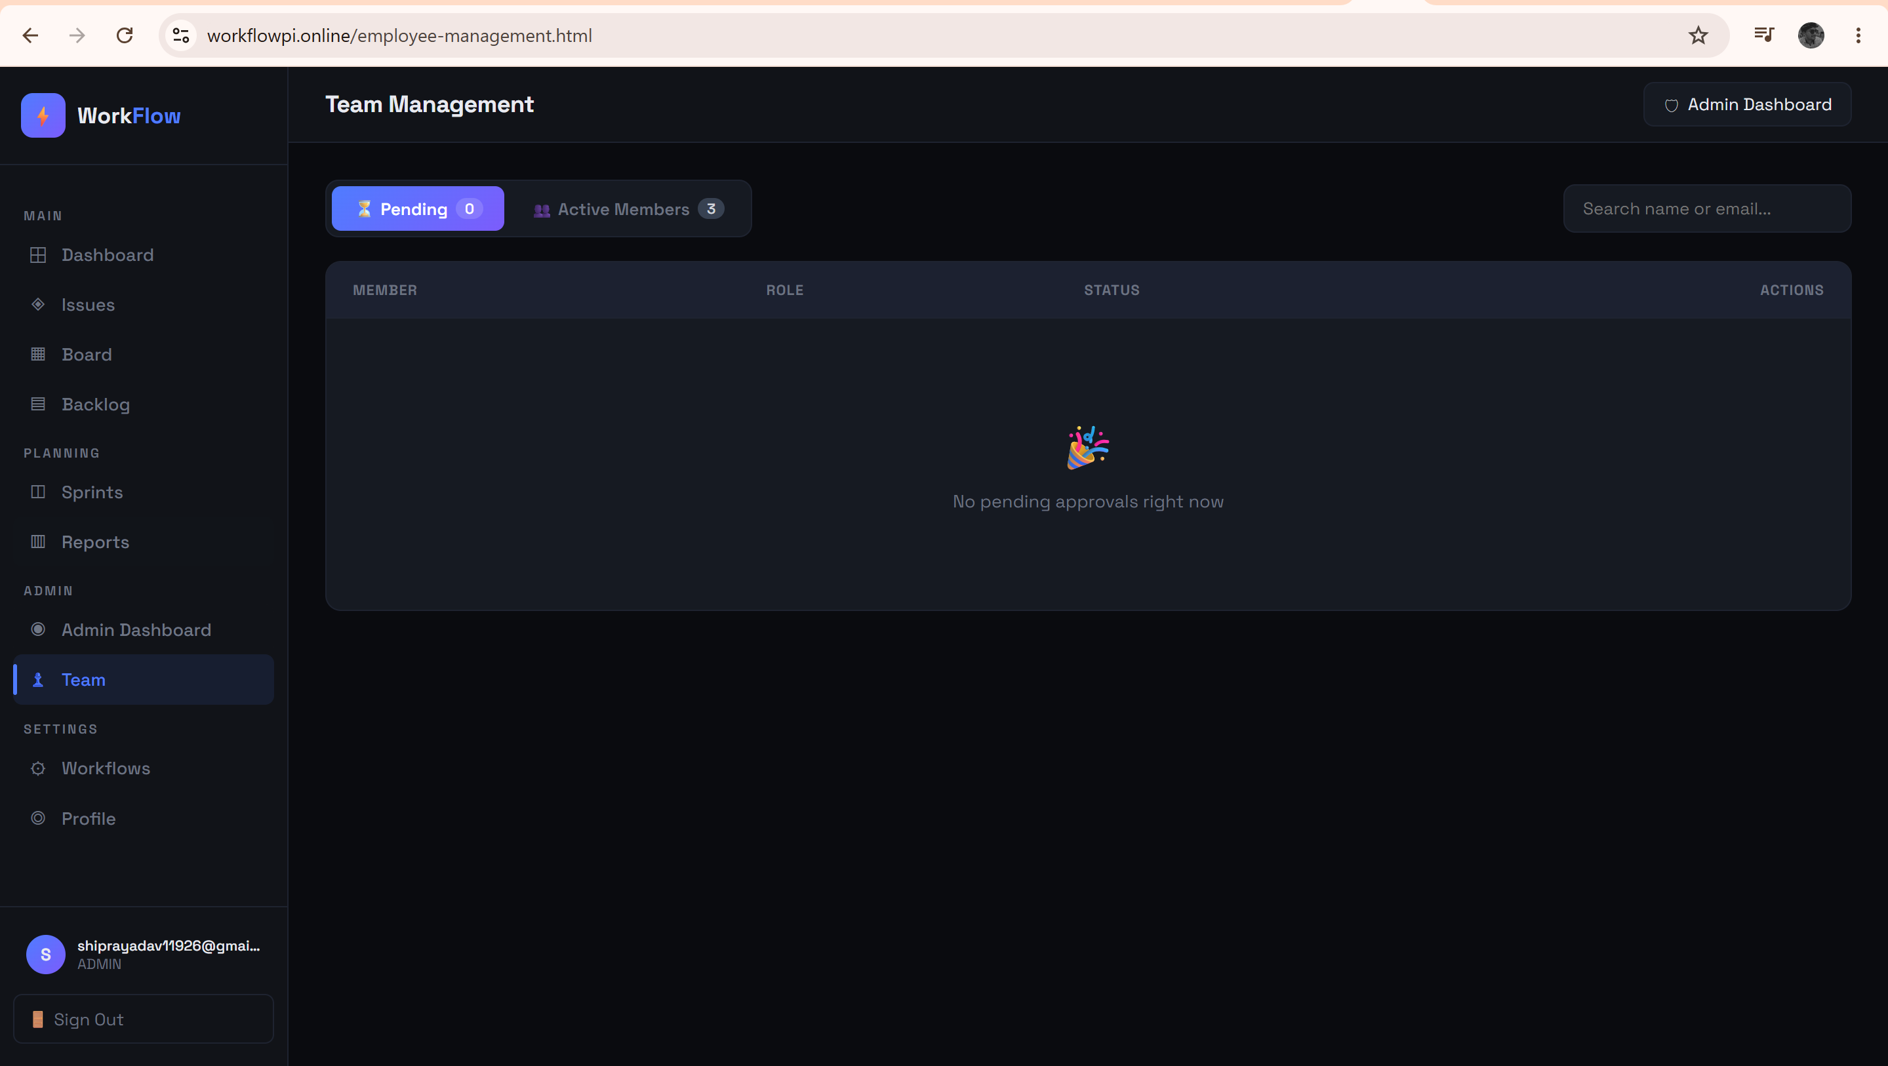
Fig. 4.5: Employee Management

4.6 Backlog Page
Lists all unscheduled issues for a project in priority order, supporting drag-and-drop reordering (POST /api/backlog/{projectId}/reorder) and one-click assignment of an issue into a selected sprint (PUT /api/backlog/add-to-sprint/{issueId}/{sprintId}). Includes a collapsible hierarchy view for epics/stories/sub-tasks.
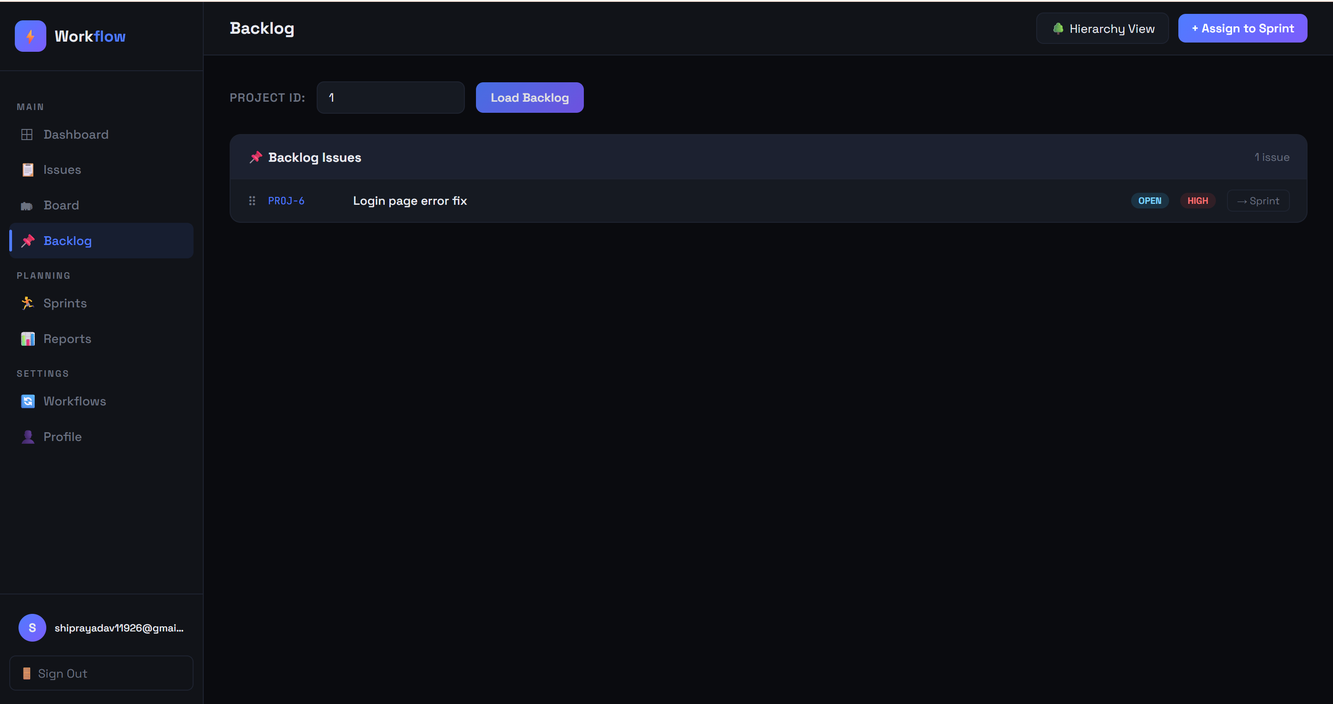
Fig. 4.6: Backlog Page
4.7 Kanban Board
The core Agile visualization screen: renders a board's columns (e.g., To Do, In Progress, In Review, Done) as configured via BoardColumn entities, with cards representing issues that can be dragged between columns. Each move triggers PUT /api/boards/{boardId}/card/{cardId}/move, and WIP limits configured per column are enforced/highlighted.
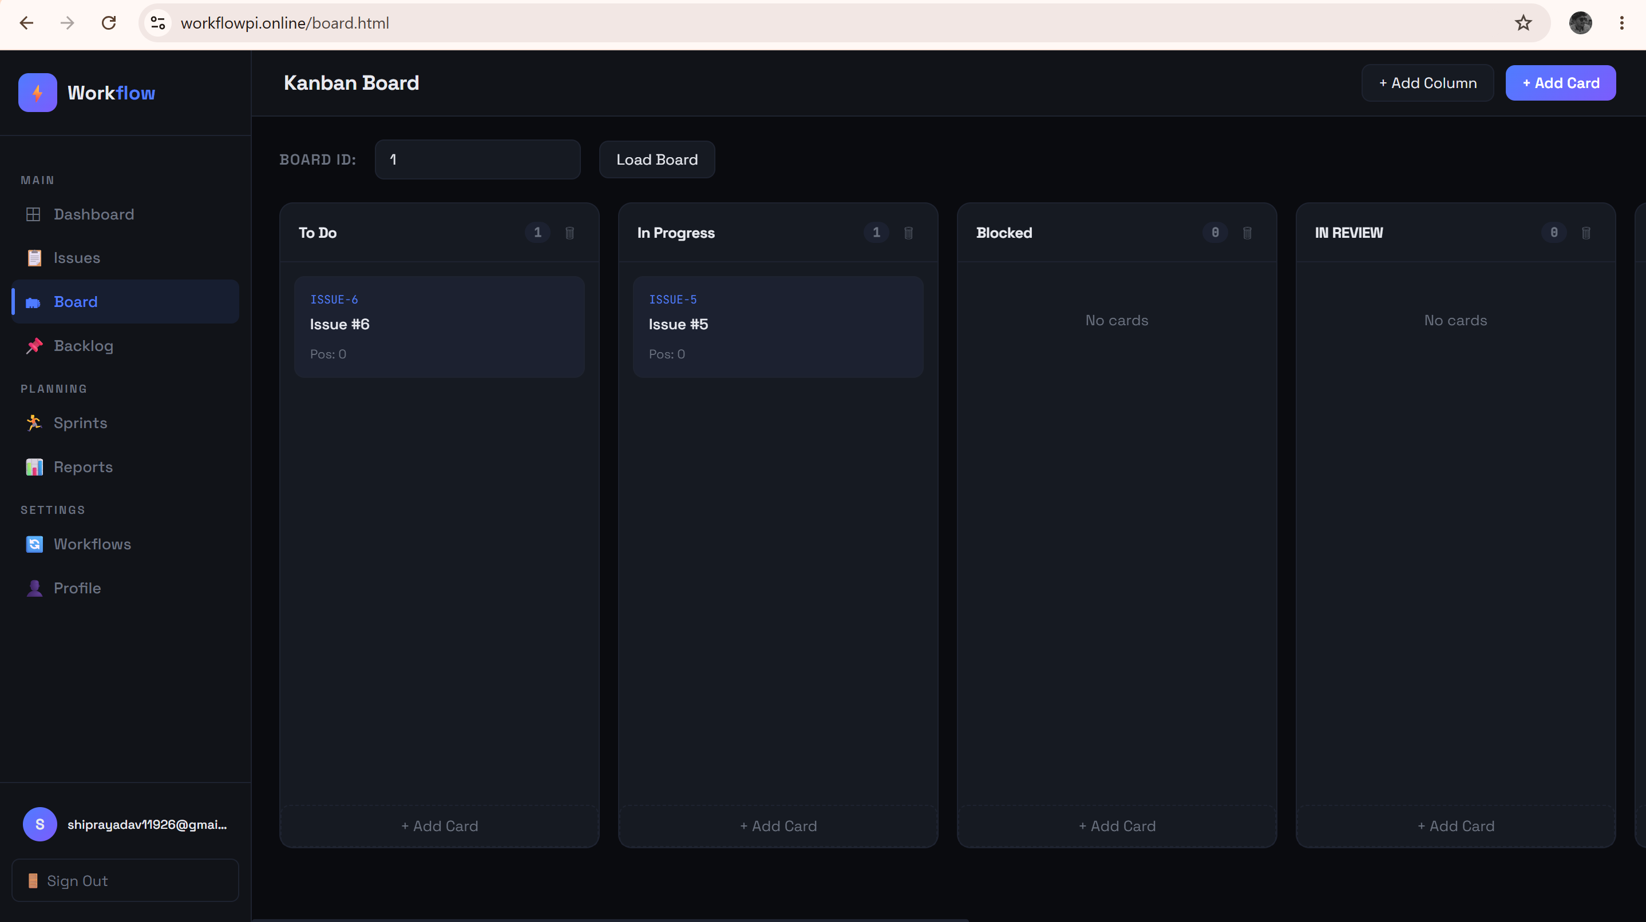
Fig. 4.7: Kanban Board

4.8 Issue Tracker
A searchable, filterable table/list of all issues in the organization, showing issue key, title, type, priority, status, and assignee. Supports creating new issues (POST /api/issues/createIssue), opening an issue detail view with comments, and performing status transitions constrained by the active workflow.
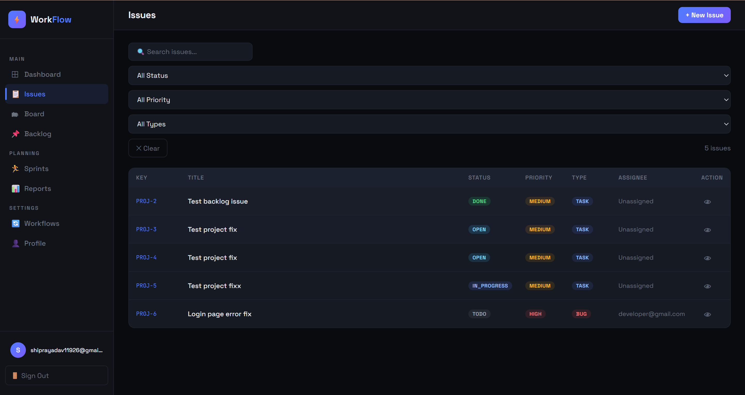
Fig. 4.8: Issue Tracker

4.9 Sprint Planning
Lists all sprints for a project with their state (Planned/Active/Completed), and allows creating a new sprint, starting/ending the active sprint, and viewing a live burndown chart driven by GET /api/sprints/{sprintId}/burndown.
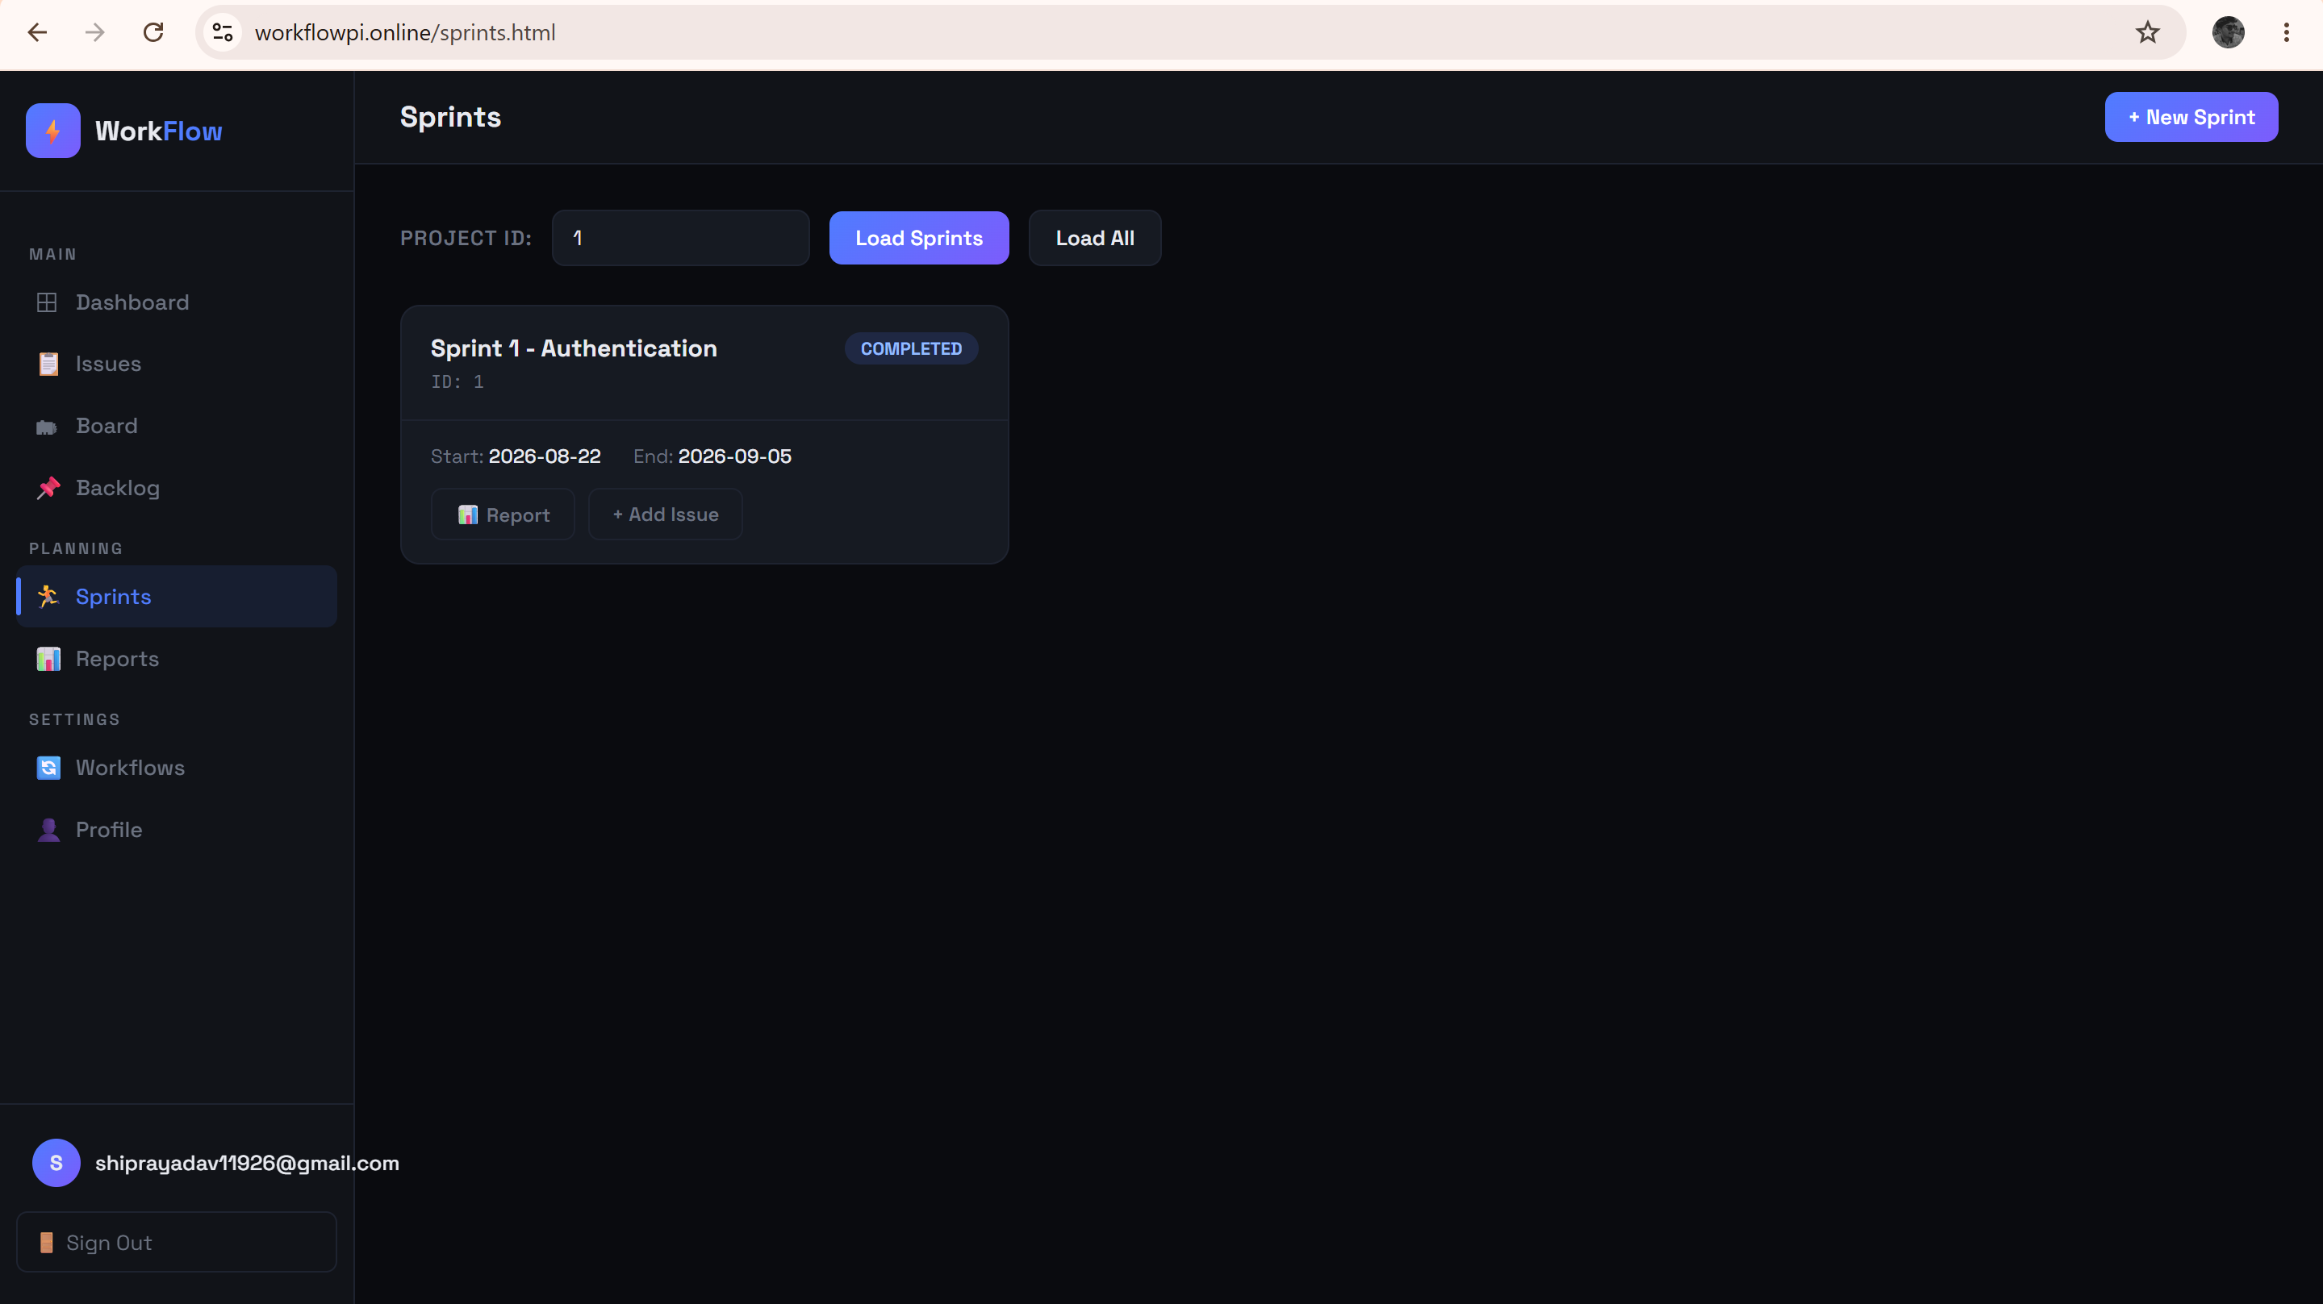
Fig. 4.9: Sprint Planning

4.10 Workflow Designer
Lets managers/admins define and edit the status-transition rules (WorkFlowTransaction) that govern how issues move through their lifecycle, including which roles are permitted to trigger each transition.
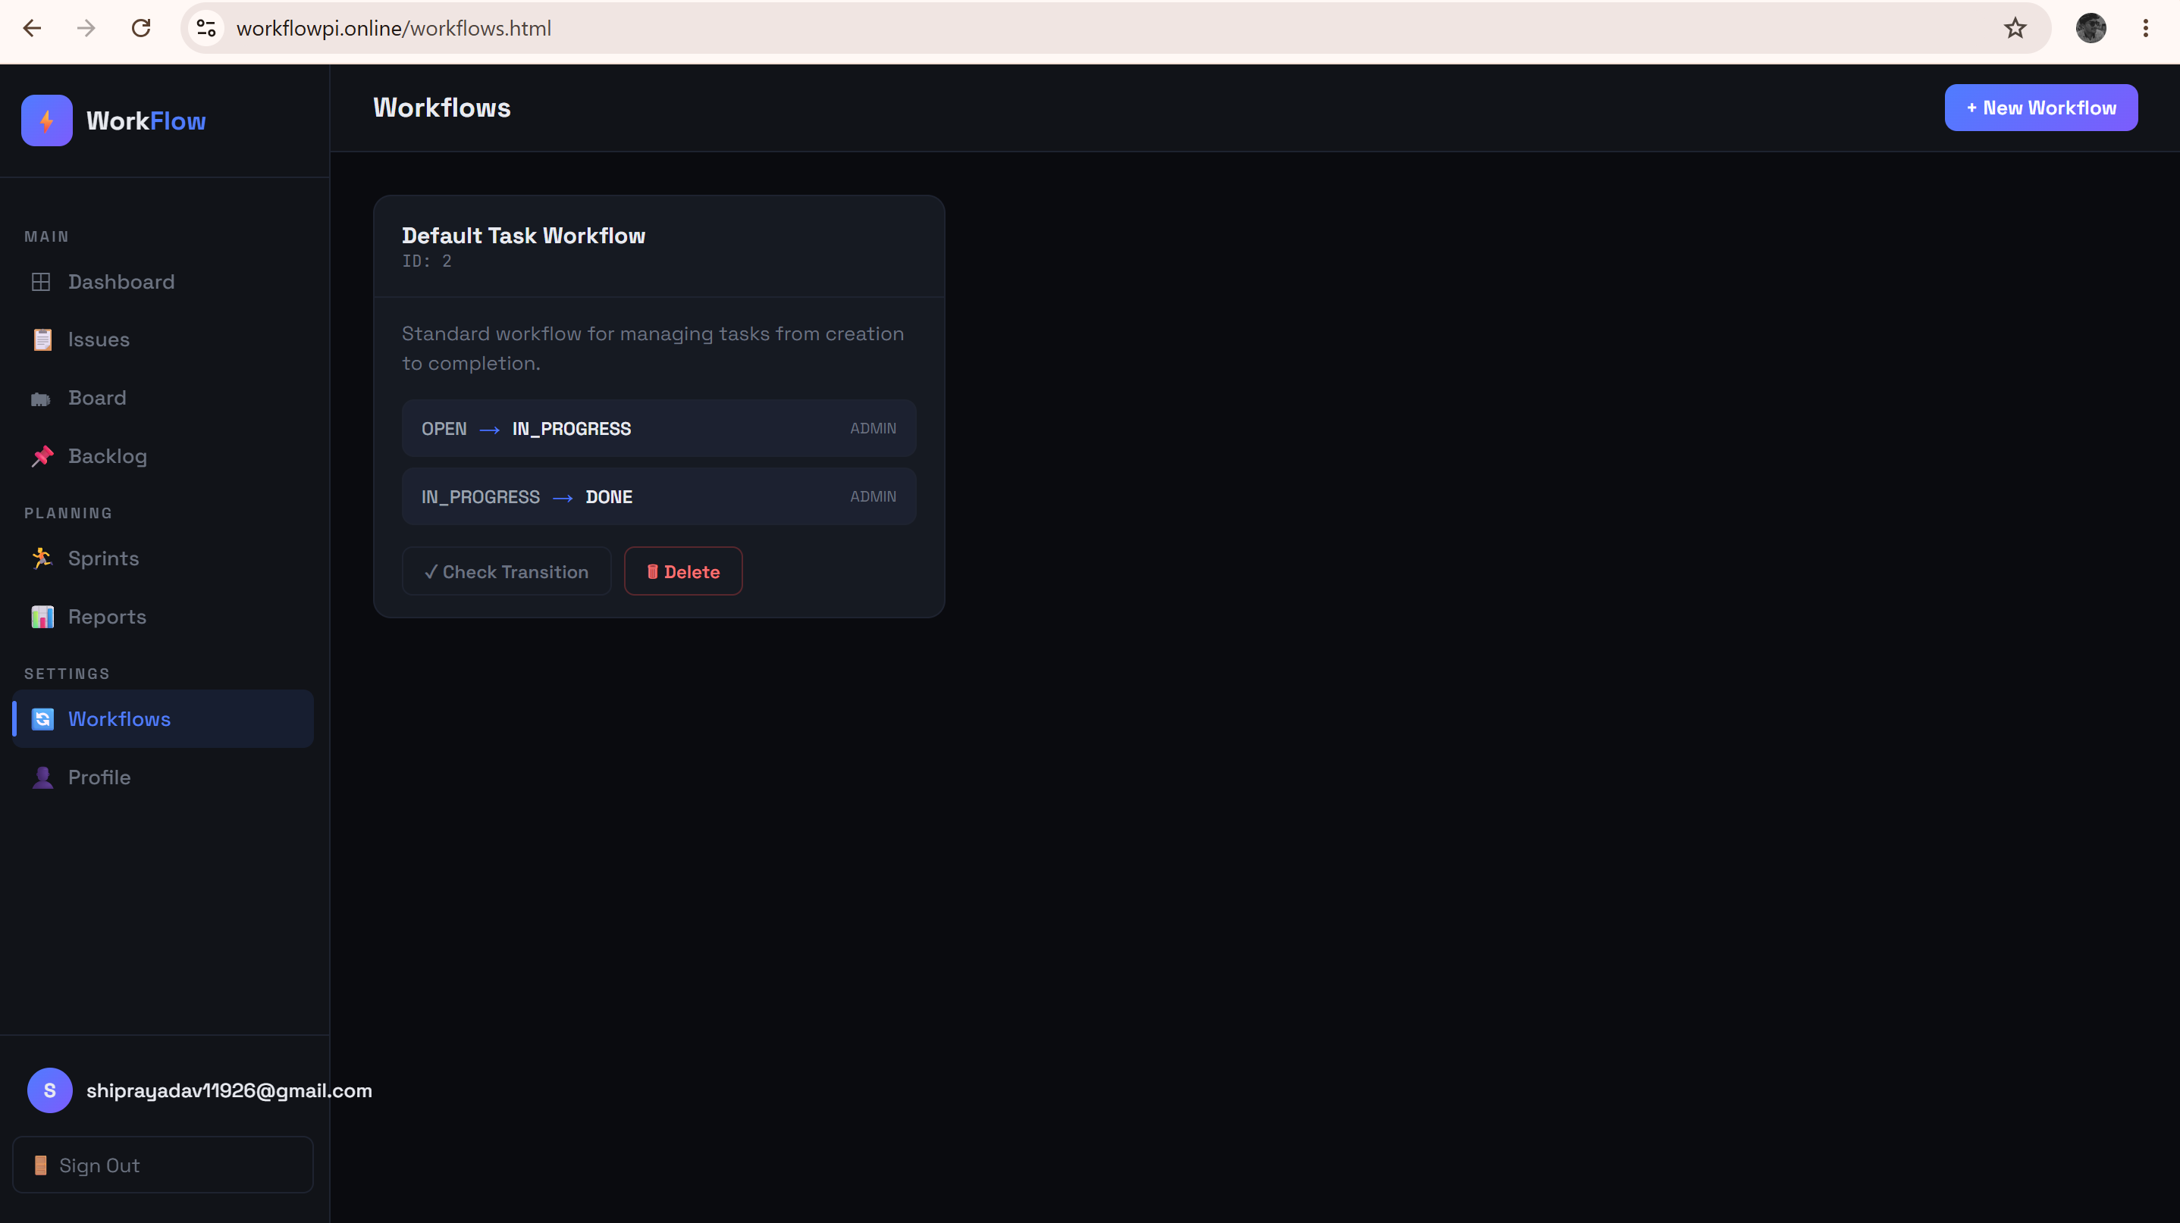
Fig. 4.10: Workflow Designer

4.11 Reports & Analytics
Aggregates the reporting APIs into visual dashboards: burndown charts, velocity trends across sprints, cumulative flow diagrams, epic progress bars, and workload-distribution charts showing issue count per team member.
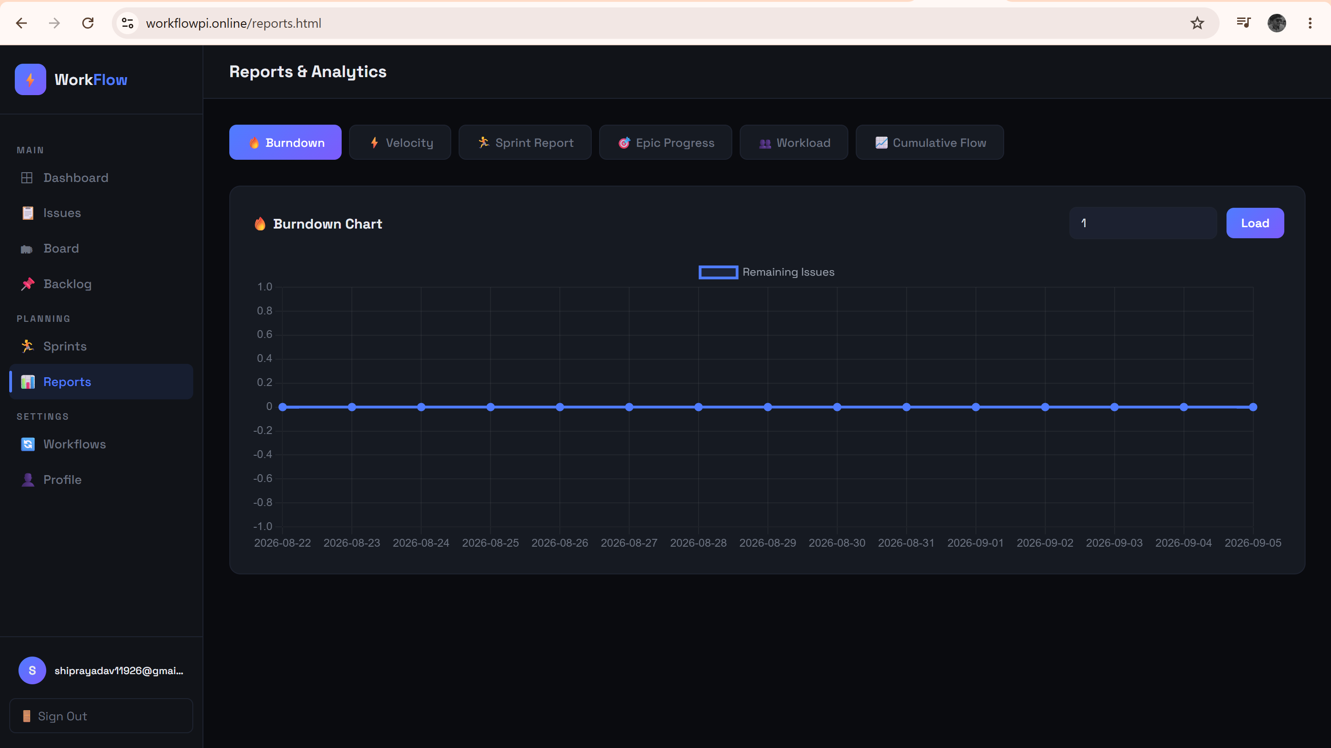
Fig. 4.11: Reports & Analytics

4.12 User Profile
Allows the logged-in user to view and update their own profile information (department, designation) via the UserProfileUpdate module, and to initiate a password change.
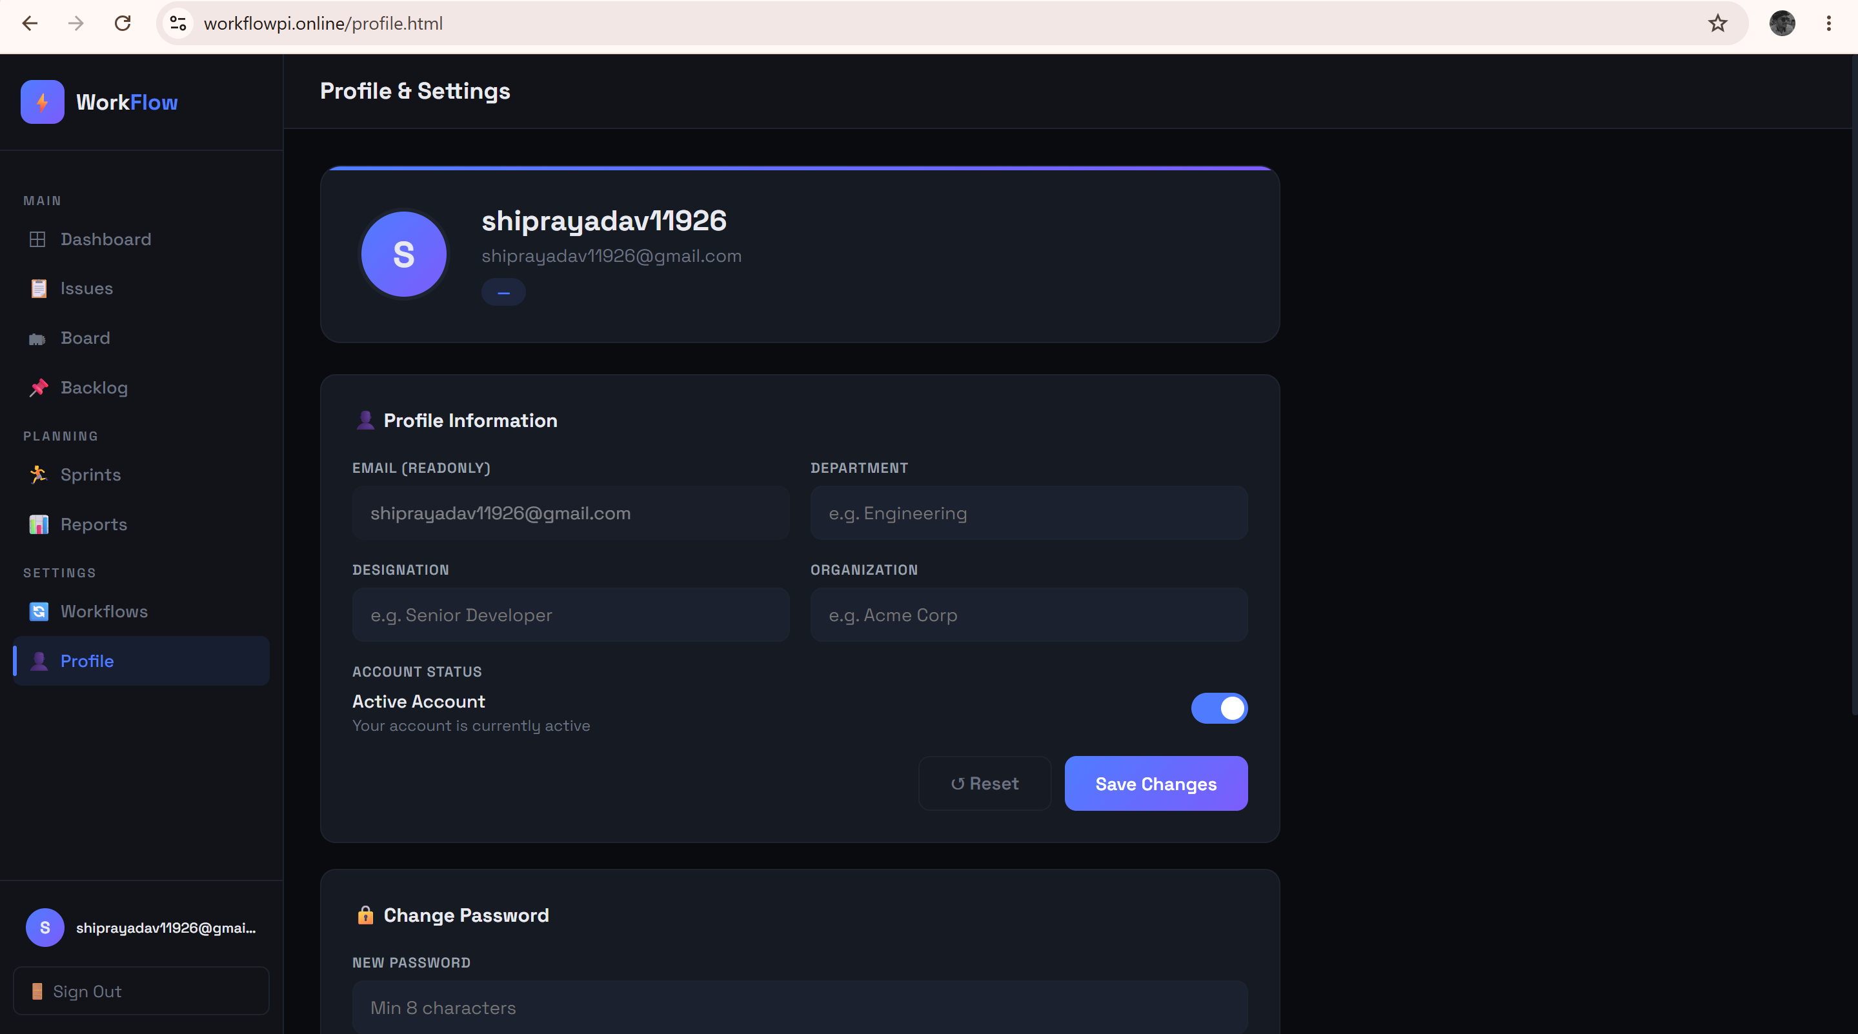
Fig. 4.12: User Profile

4.13 Password Reset
A minimal, focused page used after a user follows the password-reset link emailed to them; it accepts a new password and submits it along with the reset token to POST /api/user-auth/reset-password.
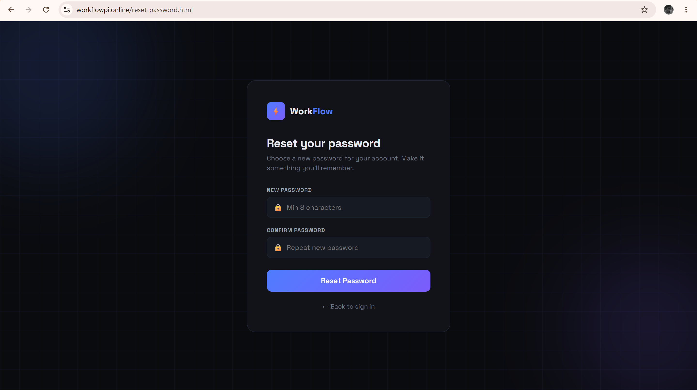
Fig. 4.13: Password Reset

CHAPTER 5
RESULT AND DISCUSSION
- Testing Methodology
The Task Management System was tested primarily through manual and Postman-driven functional testing of every REST endpoint, complemented by end-to-end verification through the frontend UI for each of the fourteen pages. Testing was carried out in layers: unit-level sanity checks on service methods (e.g., verifying organization-scoped filtering logic), integration testing of the full request path (Controller → Service → Repository → MySQL) using Postman collections against a locally running instance, and manual UI walkthroughs to confirm that the frontend correctly reflected backend state changes (e.g., a card moved on the board correctly persisting its new column and position).
Special attention was given to negative/security test cases — attempting to access or modify resources belonging to a different organization, calling admin-only endpoints with a non-admin token, and calling protected endpoints without any token — to validate that the security layer behaved correctly under adversarial input rather than only the happy path.
- Functional Test Cases and Results
Test ID | Test Case | Expected Result | Status
TC-01 | Register a new organization | Organization created with status PENDING | Pass
TC-02 | Register a user under a PENDING organization | User created with status PENDING; login blocked | Pass
TC-03 | Admin approves a pending user | User status changes to ACTIVE; login succeeds | Pass
TC-04 | Login with correct credentials | JWT returned in AuthResponseDTO | Pass
TC-05 | Login with incorrect password | 401 Unauthorized returned | Pass
TC-06 | Access protected API without token | 401/403 returned by JWTAuthenticationFilter chain | Pass
TC-07 | Access another organization's issue by guessing ID | 404/403 — request rejected due to organization scoping | Pass
TC-08 | Access /api/admin/** as non-ADMIN role | 403 Forbidden returned | Pass
TC-09 | Create an issue with valid data | Issue persisted with generated issueKey | Pass
TC-10 | Move a board card to a column at its WIP limit | Move blocked / warning surfaced | Pass
TC-11 | Transition issue status not allowed by workflow for caller's role | Transition rejected | Pass
TC-12 | Create a sprint and assign backlog issues | Issues linked to sprint; backlog updated | Pass
TC-13 | Start and end a sprint | SprintState transitions PLANNED→ACTIVE→COMPLETED | Pass
TC-14 | Upload a file attachment to an issue | File stored on Cloudinary; metadata persisted | Pass
TC-15 | Fetch burndown report for an active sprint | JSON burndown series returned | Pass
TC-16 | Forgot-password request | Reset email dispatched with time-bound token | Pass

- Non-Functional Testing
Quality Attribute | Observation
Security | Verified JWT validation, BCrypt hashing, RBAC enforcement, and cross-tenant IDOR prevention using Postman with tokens from two different organizations.
Usability | All fourteen pages verified for a consistent dark-theme layout and responsive behaviour across desktop and mobile breakpoints.
Portability | Application built and run successfully as a Docker container using the provided multi-stage Dockerfile, independent of host machine's local Java/Maven installation.
Maintainability | Layered architecture (Controller/Service/Repository/Entity) verified to keep business logic out of controllers, confirmed via code review of each module.
Performance (indicative) | Indexed columns (issueKey, assigneeEmail, board_id+column_id+position, issue_id on comments) verified via @Index annotations to keep common queries efficient at the schema level.

- Discussion
The testing phase confirmed that the core value proposition of the system — secure, multi-tenant, Agile project management — was correctly implemented. The most important result was the validation of tenant isolation: every attempt to access or modify a resource belonging to a different organization, either by tampering with a request body's organizationId or by guessing a numeric primary key, was correctly rejected because the backend always derives the effective tenant from the authenticated JWT principal rather than from client-supplied data.
The workflow-engine design also proved effective in practice: because allowed status transitions and their permitted roles are stored as data (WorkFlowTransaction rows) rather than hardcoded in Java conditionals, new transitions or role restrictions can be introduced per organization without a code change, which is a meaningful step toward the kind of configurability seen in commercial tools like Jira.
A few limitations were also observed during testing. First, because `spring.jpa.hibernate.ddl-auto=update` is used for schema management, there is no formal migration history (e.g., via Flyway/Liquibase), which would be a risk in a real production rollout. Second, some read-heavy report endpoints (velocity, cumulative flow) compute aggregates on the fly at request time rather than through pre-aggregated summary tables, which is acceptable at the current demonstration scale but would need caching or materialized views under real production load. These observations directly informed the future-enhancement list in Chapter 6.

CHAPTER 6
CONCLUSION & FUTURE SCOPE
- Conclusion
The Task Management System developed in this project successfully demonstrates the practical application of enterprise Java backend development, secure REST API design, relational database modeling, and full-stack web development to a real-world software engineering problem: coordinating people, issues, and workflow across a software team. Through this project, a complete, working, Jira-inspired platform was built — covering secure JWT-based authentication, multi-tenant organization onboarding with administrative approval, comprehensive issue tracking, Kanban board mechanics, Agile sprint and backlog management, a configurable, role-aware workflow engine, cloud-backed file attachments, and multi-dimensional analytical reporting.
Beyond feature completeness, the project placed particular emphasis on the kind of engineering discipline expected in production systems: a clean layered architecture that separates controllers, services, repositories, and entities; DTOs that decouple the public API contract from internal persistence models; and, most importantly, a security-first design in which every piece of business data is strictly scoped to its owning organization at the service layer, closing off an entire category of cross-tenant data-leak and IDOR vulnerabilities. The application was also made portable and deployment-ready through a multi-stage Docker build with fully externalized configuration.
Overall, this mini project has provided substantial hands-on experience directly relevant to a Java Full Stack Developer role — spanning Spring Boot, Spring Security, JWT, Hibernate/JPA, MySQL, REST API design, and responsive frontend development — while producing a functioning, demonstrable application rather than a purely theoretical exercise.
- Future Scope
While the current version of the Task Management System fulfills its core objectives, several enhancements have been identified for future iterations:
- Real-Time Collaboration: Introducing WebSocket-based (e.g., STOMP over SockJS) live updates so that board moves, comments, and status changes are reflected instantly across all connected clients without polling.
- Notification System: Email and in-app notifications for issue assignment, mentions in comments, sprint start/end, and approaching due dates.
- Database Migration Tooling: Adopting Flyway or Liquibase for versioned schema migrations, replacing the current Hibernate auto-update strategy to make production rollouts safer and reversible.
- Advanced Analytics & AI-Based Insights: Predictive sprint-completion estimates, anomaly detection in team workload, and natural-language issue summarization using AI/LLM integration.
- OAuth2 / SSO Login: Supporting Google/GitHub/Microsoft single sign-on in addition to the current email-password flow, to reduce onboarding friction for organizations.
- Mobile Application: A dedicated Android/iOS (or cross-platform Flutter/React Native) client consuming the same REST API for on-the-go issue triage and board updates.
- Microservices Decomposition: Splitting the current modular monolith into independently deployable services (e.g., Auth Service, Issue Service, Reporting Service) communicating via the OpenFeign clients already scaffolded in the codebase (IssueClient, UserClient), paired with a service registry and API gateway.
- Automated CI/CD Pipeline: Extending the existing GitHub/Jenkins/Docker integration endpoints into a fully automated pipeline that builds, tests, and deploys on every merge, and automatically transitions linked issues based on commit/PR/deployment events.
- Caching Layer: Introducing Redis to cache frequently read, rarely changing data such as workflow definitions and board column configurations, reducing database load for report generation.

CHAPTER 7
REFERENCES
- Spring Boot Reference Documentation. Spring Team, VMware. Retrieved from https://docs.spring.io/spring-boot/documentation.html
- Spring Security Reference Documentation. Spring Team, VMware. Retrieved from https://docs.spring.io/spring-security/reference/
- Spring Data JPA Reference Documentation. Spring Team, VMware. Retrieved from https://docs.spring.io/spring-data/jpa/reference/
- Oracle Corporation. (2024). MySQL 8.4 Reference Manual. Retrieved from https://dev.mysql.com/doc/refman/8.4/en/
- JJWT — Java JWT: JSON Web Token for Java and Android. Retrieved from https://github.com/jwtk/jjwt
- Hibernate ORM User Guide. Red Hat. Retrieved from https://hibernate.org/orm/documentation/
- Cloudinary Developer Documentation. Retrieved from https://cloudinary.com/documentation
- Apache Maven Documentation. Apache Software Foundation. Retrieved from https://maven.apache.org/guides/
- Docker Documentation — Multi-stage builds. Docker Inc. Retrieved from https://docs.docker.com/build/building/multi-stage/
- Mozilla Developer Network. Fetch API. Retrieved from https://developer.mozilla.org/en-US/docs/Web/API/Fetch_API
- Postman Learning Center. Retrieved from https://learning.postman.com/
- Atlassian. Jira Software — Agile Project Management. Retrieved from https://www.atlassian.com/software/jira

APPENDICES
REPRESENTATIVE SOURCE CODE
This appendix includes representative, source code from key modules of the Task Management System, illustrating the security implementation, domain model, and REST controller design discussed in Chapter 3.

A.1 Security Configuration (SecurityConfig.java)
@Configuration
public class SecurityConfig {
@Autowired
private JWTAuthenticationFilter jwtAuthenticationFilter;
@Bean
public PasswordEncoder passwordEncoder() {
return new BCryptPasswordEncoder();
}
@Bean
public SecurityFilterChain filterChain(HttpSecurity http) throws Exception {
http
.cors(cors -> cors.configurationSource(corsConfigurationSource()))
.csrf(csrf -> csrf.disable())
.sessionManagement(session ->
session.sessionCreationPolicy(SessionCreationPolicy.STATELESS))
.authorizeHttpRequests(auth -> auth
.requestMatchers(
"/", "/*.html", "/favicon.ico", "/css/**", "/js/**", "/images/**",
"/api/user-auth/register", "/api/user-auth/login",
"/api/user-auth/forgot-password", "/api/user-auth/reset-password",
"/api/organizations/register", "/api/organizations"
).permitAll()
.requestMatchers("/api/admin/**").hasRole("ADMIN")
.anyRequest().authenticated())
.addFilterBefore(jwtAuthenticationFilter,
UsernamePasswordAuthenticationFilter.class);
return http.build();
}
}

A.2 JWT Authentication Filter (JWTAuthenticationFilter.java)
@Component
public class JWTAuthenticationFilter extends OncePerRequestFilter {
@Autowired private JWTUtil jwtUtil;
@Autowired private CustomUserDetailsService userDetailsService;
@Autowired private TokenBlockService tokenBlockService;
@Override
protected void doFilterInternal(HttpServletRequest request,
HttpServletResponse response, FilterChain filterChain)
throws ServletException, IOException {
String header = request.getHeader("Authorization");
String token = null;
if (StringUtils.hasText(header) && header.startsWith("Bearer ")) {
token = header.substring(7);
}
if (token != null && jwtUtil.validateToken(token)
&& !tokenBlockService.isBlocked(token)
&& SecurityContextHolder.getContext().getAuthentication() == null) {
String userEmail = jwtUtil.getUserEmail(token);
UserDetails userDetails = userDetailsService.loadUserByUsername(userEmail);
UsernamePasswordAuthenticationToken authentication =
new UsernamePasswordAuthenticationToken(
userDetails, null, userDetails.getAuthorities());
authentication.setDetails(
new WebAuthenticationDetailsSource().buildDetails(request));
SecurityContextHolder.getContext().setAuthentication(authentication);
}
filterChain.doFilter(request, response);
}
}

A.3 Issue Entity (Issue.java)
@Data
@Entity
@Table(name = "issues", indexes = {
@Index(name = "idx_issue_key", columnList = "issueKey"),
@Index(name = "idx_issue_assignee", columnList = "assigneeEmail") })
public class Issue {
@Id @GeneratedValue(strategy = GenerationType.IDENTITY)
private Long id;
@Column(unique = true, nullable = false)
private String issueKey;
@Column(nullable = false)
private String issueTitle;
@Column(length = 5000)
private String issueDescription;
@Enumerated(EnumType.STRING) private IssueType issueType;
@Enumerated(EnumType.STRING) private IssuePriority priority;
@Enumerated(EnumType.STRING) private IssueStatus issueStatus;
private String assigneeEmail;
private String reporterEmail;
private Long projectId;
private Long sprintId;
private Long epicId;
private Long parentIssueId;
private Integer backLogPosition;
@Column(nullable = false) private Long organizationId;
private LocalDateTime createdAt = LocalDateTime.now();
private LocalDateTime updatedAt = LocalDateTime.now();
private LocalDateTime dueDate;
@ManyToMany(fetch = FetchType.EAGER)
@JoinTable(name = "issue_label",
joinColumns = @JoinColumn(name = "issue_id"),
inverseJoinColumns = @JoinColumn(name = "label_id"))
private Set<Label> labels = new HashSet<>();
}

A.4 Workflow Transaction Entity (WorkFlowTransaction.java)
@Entity
@Table(name = "workFlow_Transactions")
@Data @NoArgsConstructor @AllArgsConstructor @Builder
public class WorkFlowTransaction {
@Id @GeneratedValue(strategy = GenerationType.IDENTITY)
private Long id;
private IssueStatus fromStatus;
private IssueStatus toStatus;
private String actionName;
@Builder.Default
private Set<Role> allowedRole = new HashSet<>();
@ManyToOne
@JoinColumn(name = "workflow_id")
@JsonBackReference
private WorkFlow workFlow;
}

A.5 Issue Controller (IssueController.java — endpoint mapping excerpt)
@RestController
@RequestMapping("/api/issues")
public class IssueController {
@PostMapping("/createIssue")
public ResponseEntity<?> createIssue(@RequestBody IssueDTO dto) { ... }
@GetMapping("/{id}")
public ResponseEntity<?> getIssue(@PathVariable Long id) { ... }
@GetMapping("/assignee/{email}")
public ResponseEntity<?> getByAssignee(@PathVariable String email) { ... }
@PostMapping("/{id}/comment")
public ResponseEntity<?> addComment(@PathVariable Long id,
@RequestBody IssueComment comment) { ... }
@PatchMapping("/{id}/status")
public ResponseEntity<?> updateStatus(@PathVariable Long id,
@RequestParam String toStatus) { ... }
@GetMapping("/search")
public ResponseEntity<?> search(@RequestParam Map<String, String> filters) { ... }
}

A.6 Dockerfile
FROM maven:3.9-eclipse-temurin-17 AS build
WORKDIR /app
COPY pom.xml .
RUN mvn dependency:go-offline -B
COPY src ./src
RUN mvn clean package -DskipTests
FROM eclipse-temurin:17-jre
WORKDIR /app
COPY --from=build /app/target/TaskManagement-0.0.1-SNAPSHOT.jar app.jar
EXPOSE 9999
ENTRYPOINT ["java", "-jar", "app.jar"]

A.7 Organization Entity (Organization.java)
@Entity
@Table(name = "organizations")
@Getter @Setter @NoArgsConstructor @AllArgsConstructor @Builder
public class Organization {
@Id @GeneratedValue(strategy = GenerationType.IDENTITY)
private Long id;
@Column(nullable = false, unique = true)
private String name;
@Column(unique = true)
private String email;
@Enumerated(EnumType.STRING)
@Builder.Default
private OrganizationStatus status = OrganizationStatus.PENDING;
@Builder.Default
private LocalDateTime createdAt = LocalDateTime.now();
}

A.8 User Registration DTO and Admin Approval Controller
@Data
public class RegisterRequestDTO {
private String userName;
private String userOfficialEmail;
private String password;
private Role role;
private Long organizationId;
}
@RestController
@RequestMapping("/api/admin")
public class AdminController {
@GetMapping("/pending-users")
public ResponseEntity<?> getPendingUsers() { ... }
@PutMapping("/approve/{userId}")
public ResponseEntity<?> approveUser(@PathVariable Long userId) { ... }
@PutMapping("/reject/{userId}")
public ResponseEntity<?> rejectUser(@PathVariable Long userId) { ... }
}
A.9 Project Links
GitHub Repository:
github.com/prashantpiyush1111/task-management-system
Live Web Application:
Workflowpi.online

